Contents

Demo 1: Azure ML 2

Create a new instance of Azure ML 2

Launch Azure Machine Learning Studio 3

Create Compute Instance 5

Create Compute Cluster 11

Create Azure Auto ML 12

Designer (drag drop) 15

Creating Custom Model (use powerplatformopenau123sgp) 24

Warning 25

EAST US 2 not support fine tuning 25

Create new instance in different region (west- Europe) 25

Training data 28

Use the model 36

NOTE this takes 10-15 minutes 39

Test under Completions 39

Positive – I am very happy today 39

Negative - tomorrow will be tough day 39

DEMO 2: Computer Vison 39

Clone Git Hub Repo 40

Review VM 42

User the same Azure OpenAI Instance 43

Configure Networking 43

Click on + Private Endpoint 44

Create a private endpoint – Basics 46

Create a private endpoint – Resource 47

Create a private endpoint – Virtual Network 47

Create a private endpoint – DNS 48

Create a private endpoint – Tags 48

Create a private endpoint – Review & Create 49

Private endpoint 51

3 - Click on Private Resource 51

Private endpoint connections 52

Disable Firewall and virtual network 52

Now we cant access this from public Intranet 53

DEMO 3: Azure AI Content Safety 53

{Azure Content Safety 53

Create a new Content Safety instance 54

Create Content Safety – Basics 54

Create Content Safety – Network 55

Create Content Safety – Identity 55

Create Content Safety – Tags 56

Create Content Safety – Review + Create 56

Conent Safety - Instance 57

Analyzing Text 58

Params 59

Header 59

Body : 59

Analyzing Images 61

Copy image and paste in Postman – Nature 63

Copy image and paste in Postman – Bullets 64

Postman screenshots 65

# Demo 1: Azure ML

## Create a new instance of Azure ML

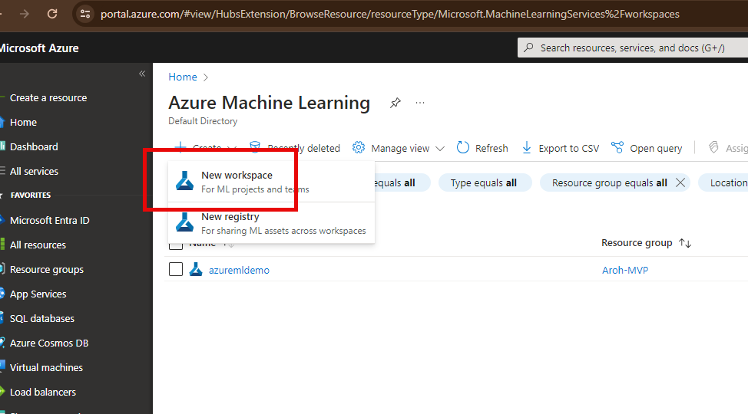

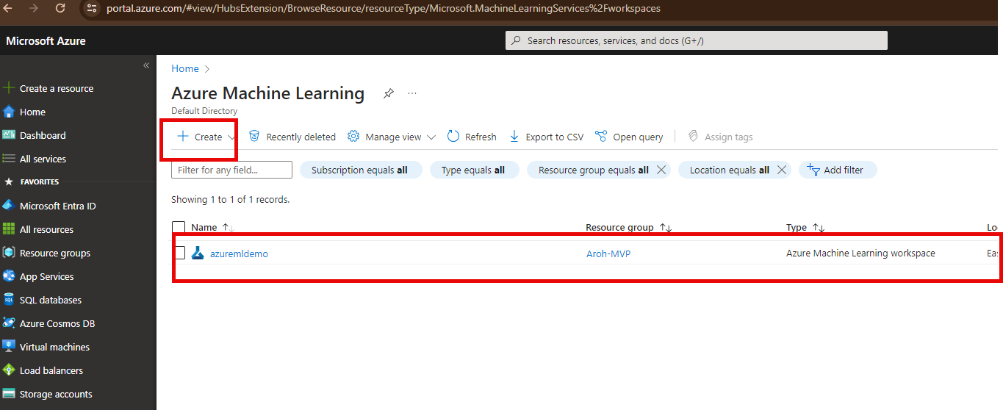

### Launch Azure Machine Learning Studio

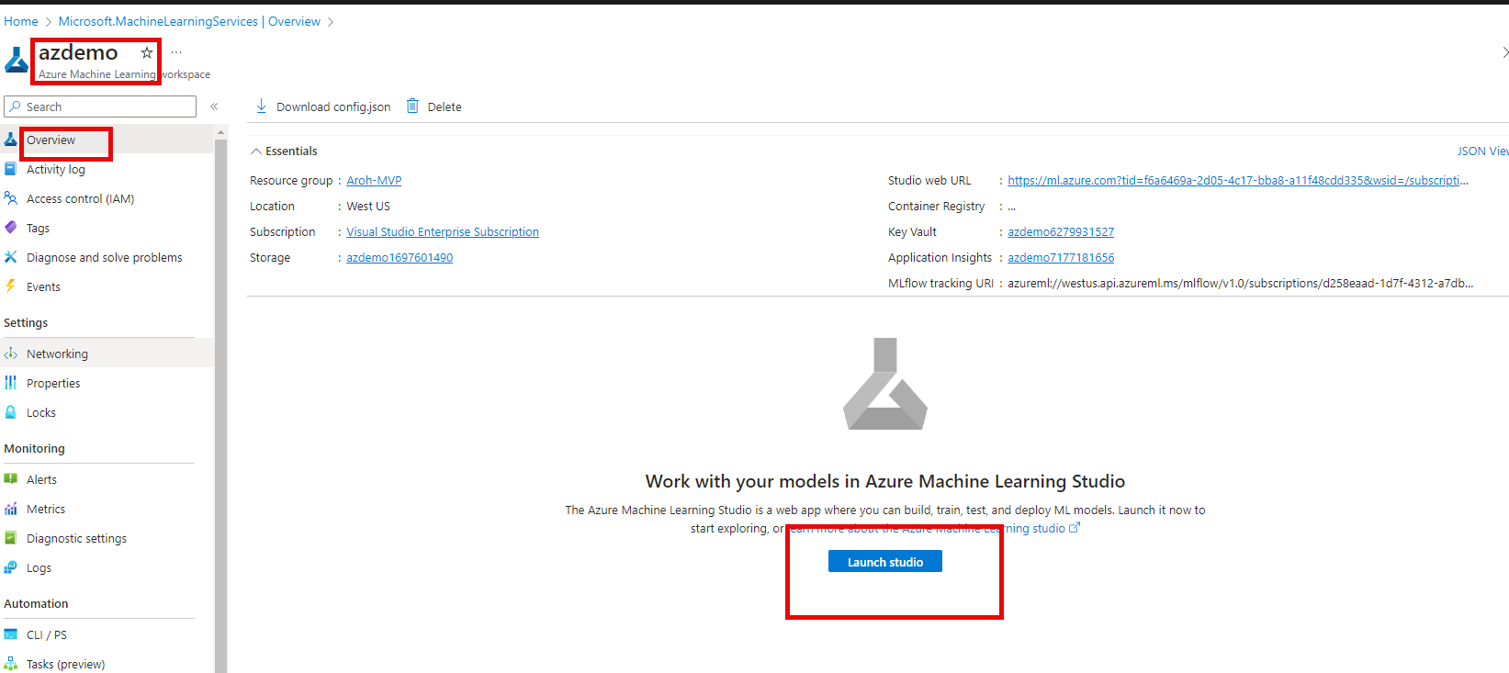

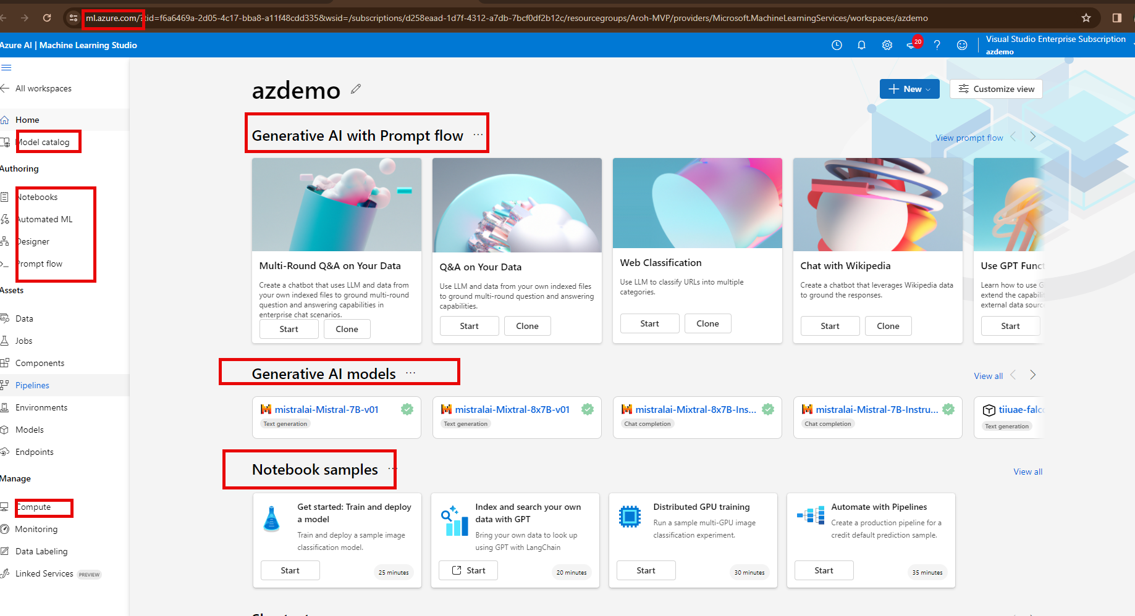

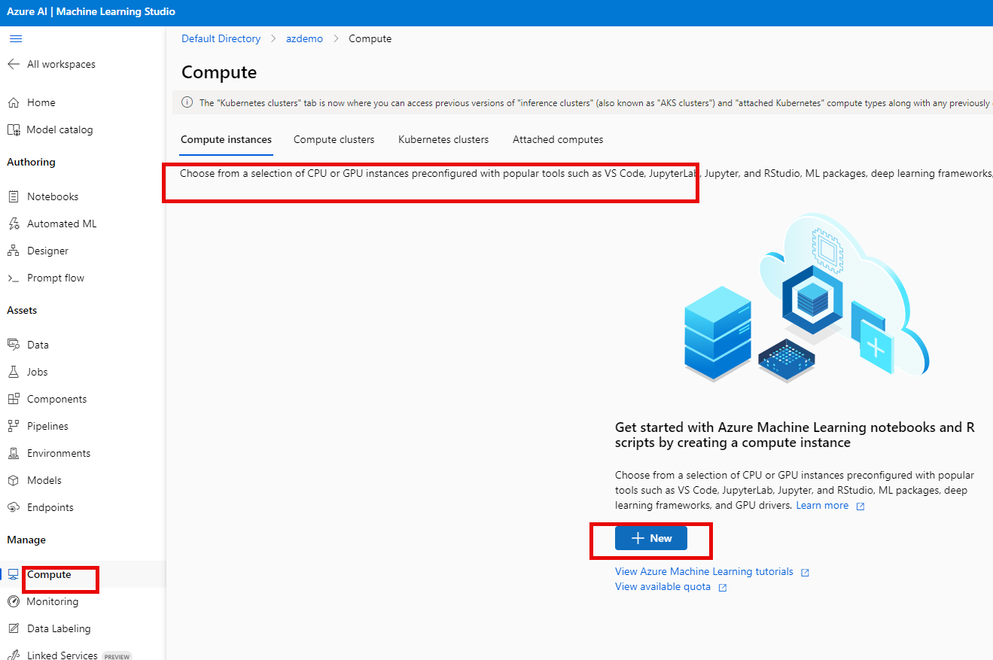

### Create Compute Instance

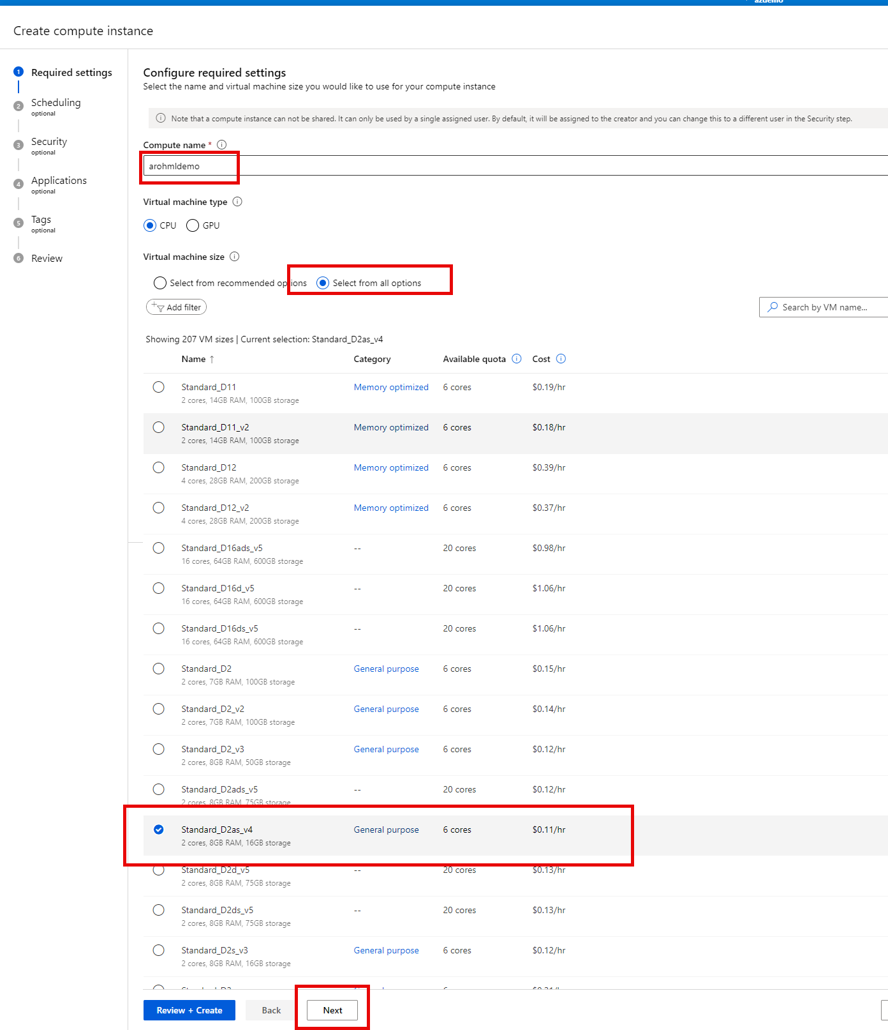

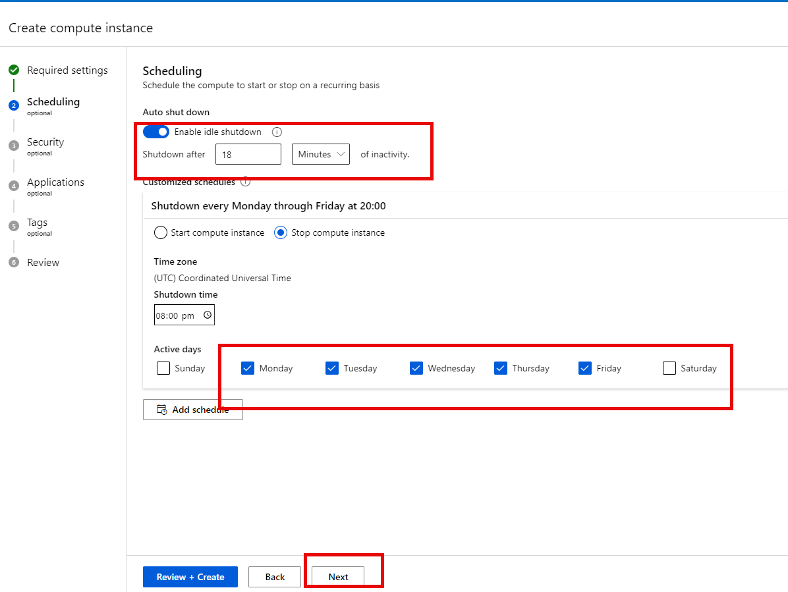

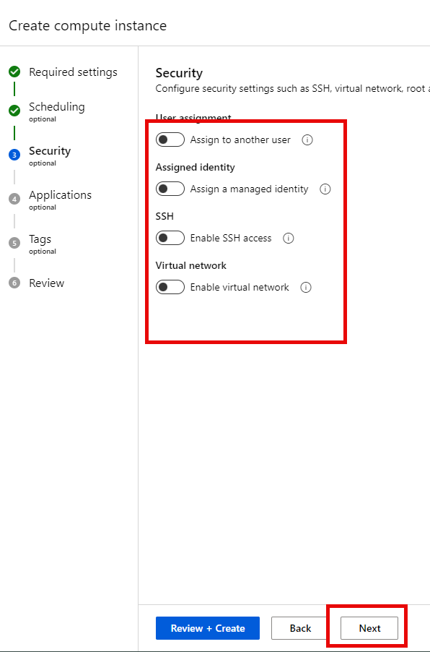

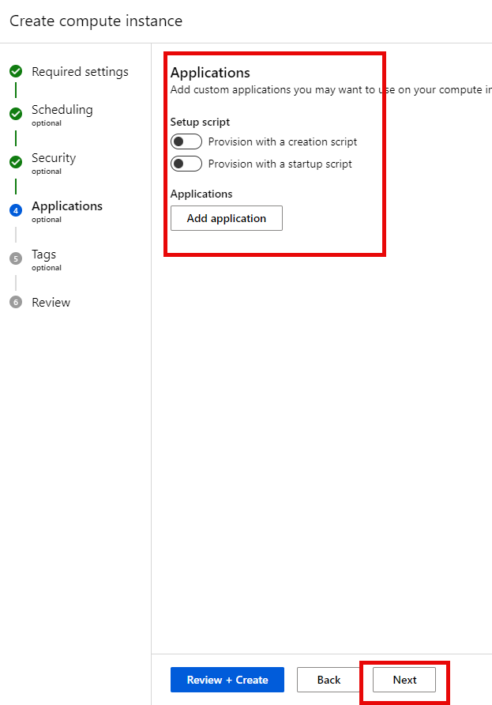

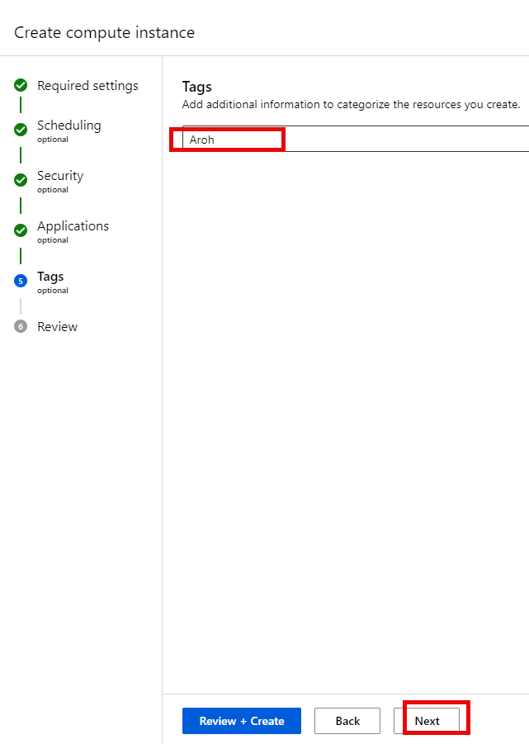

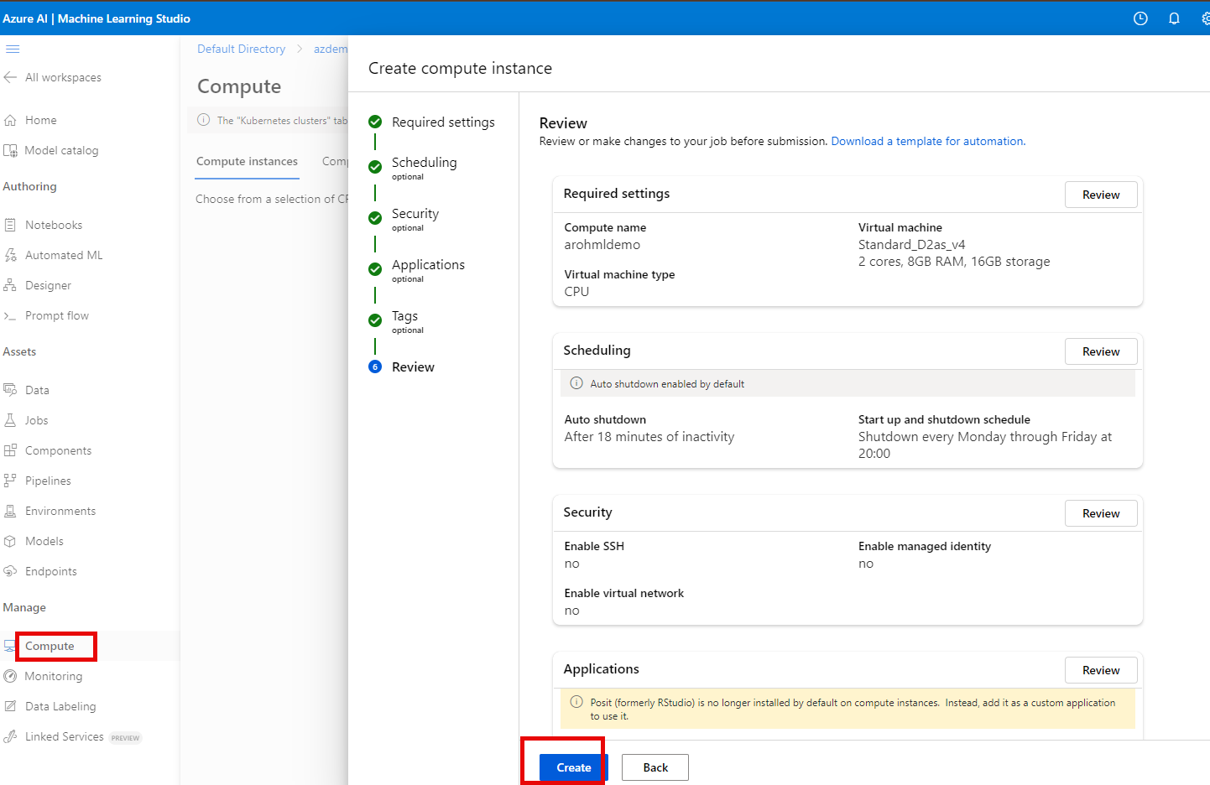

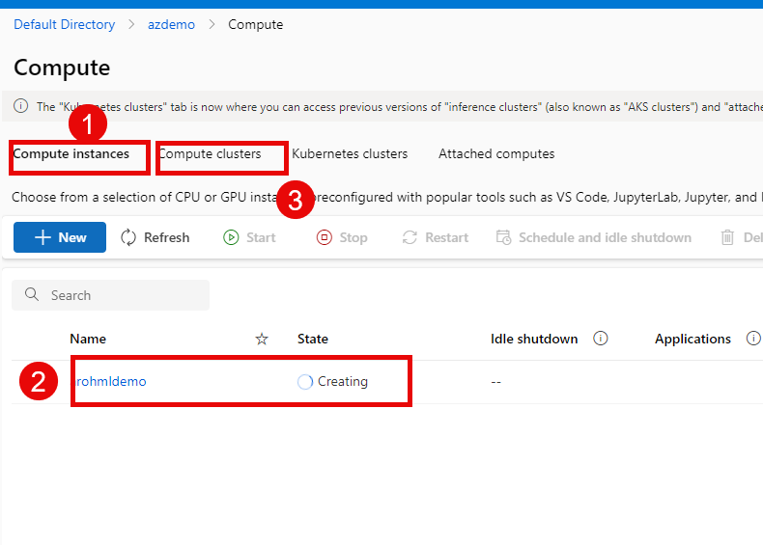

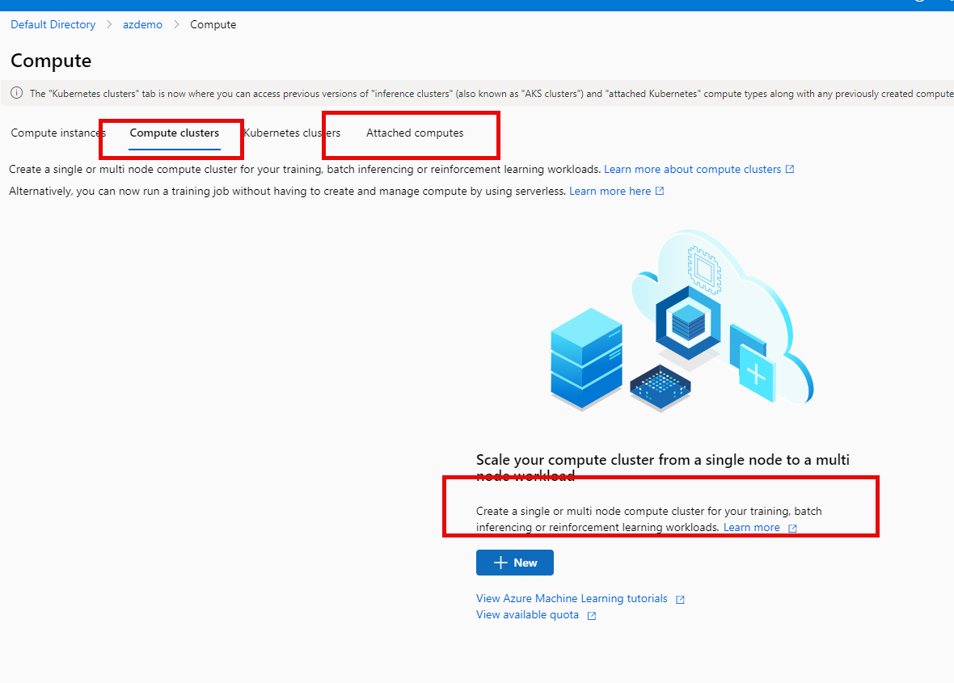

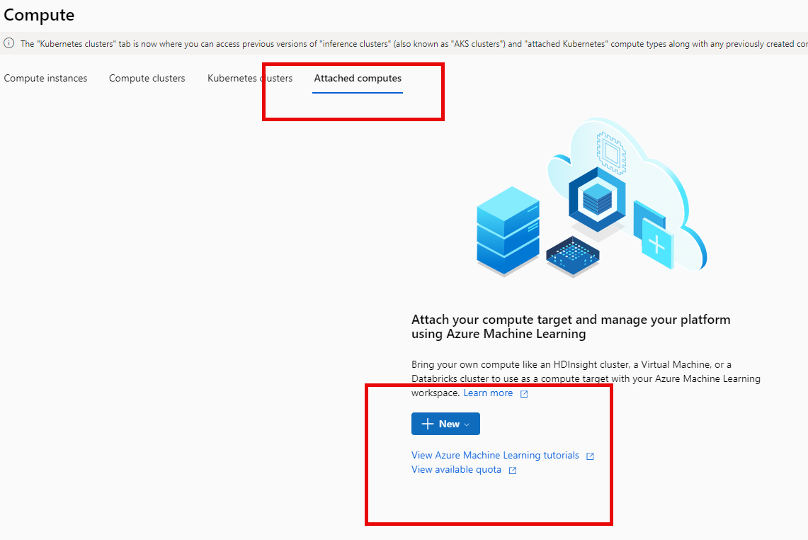

### Create Compute Cluster

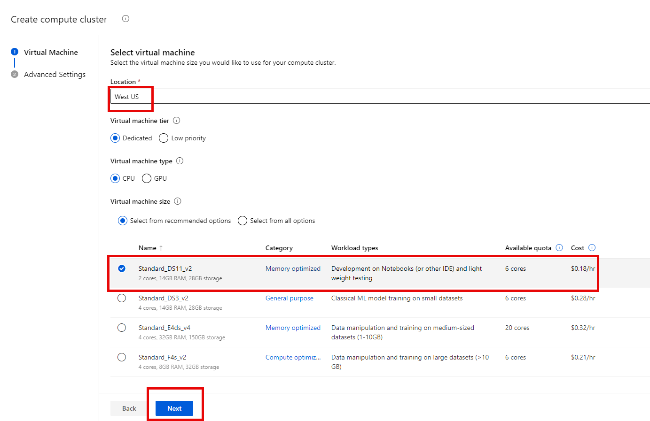

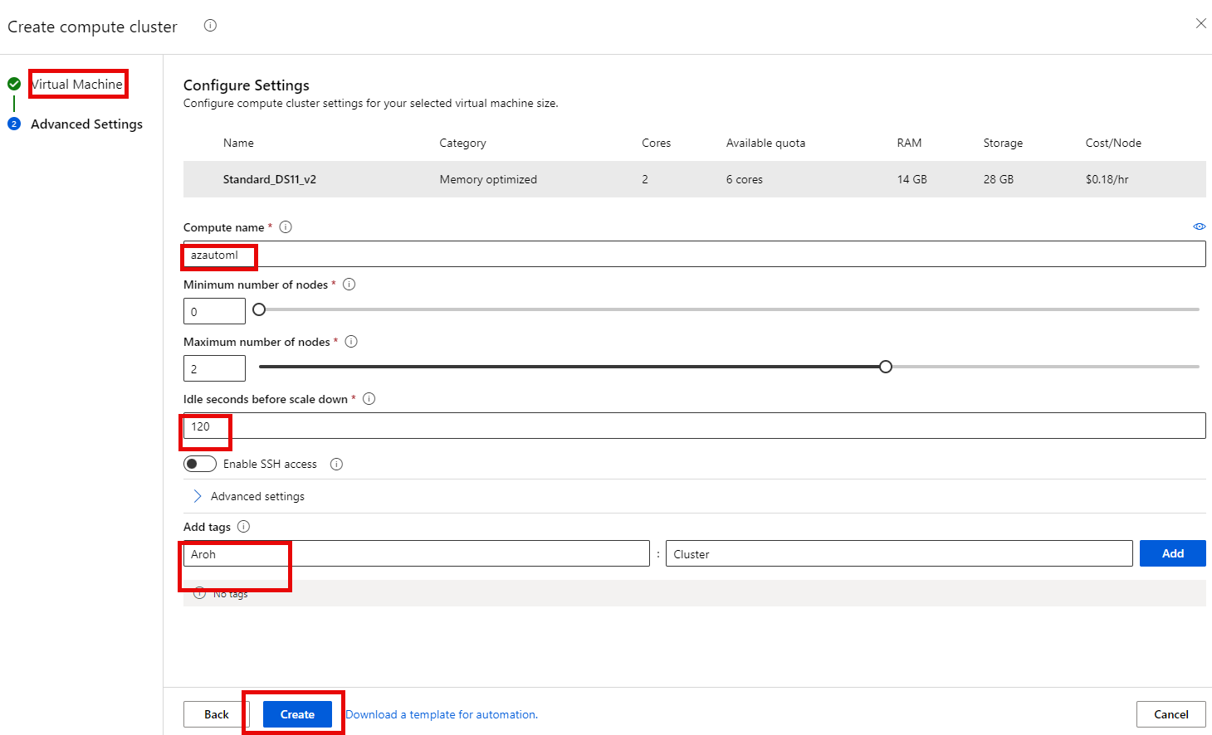

#### Compute instance Apps – JupyterLab Jupyter VS Code

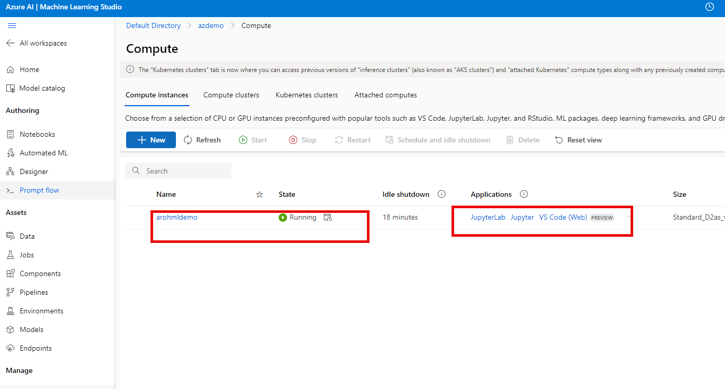

### Create Azure Auto ML

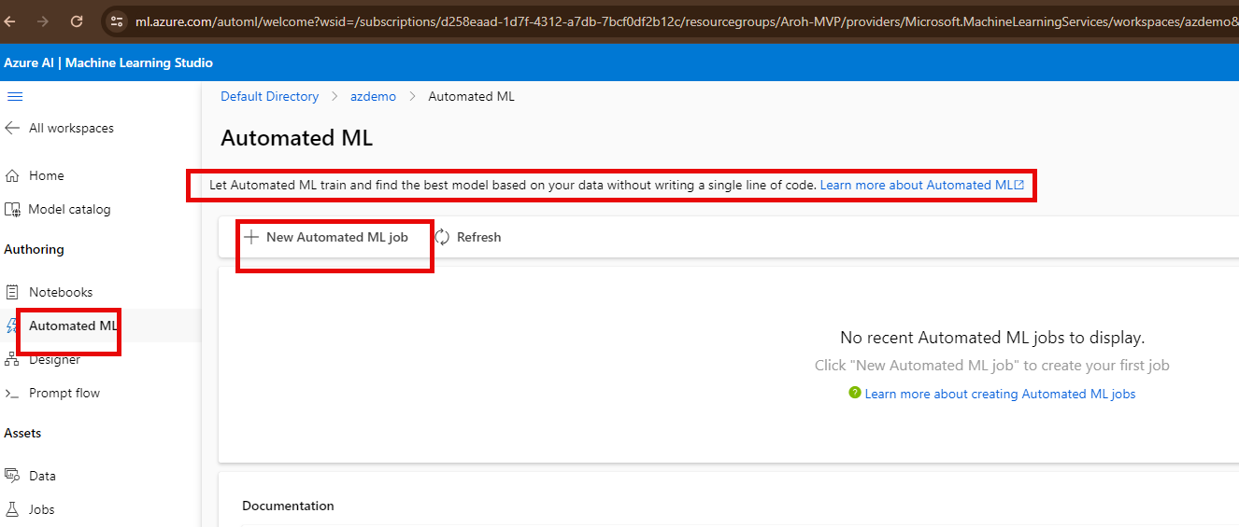

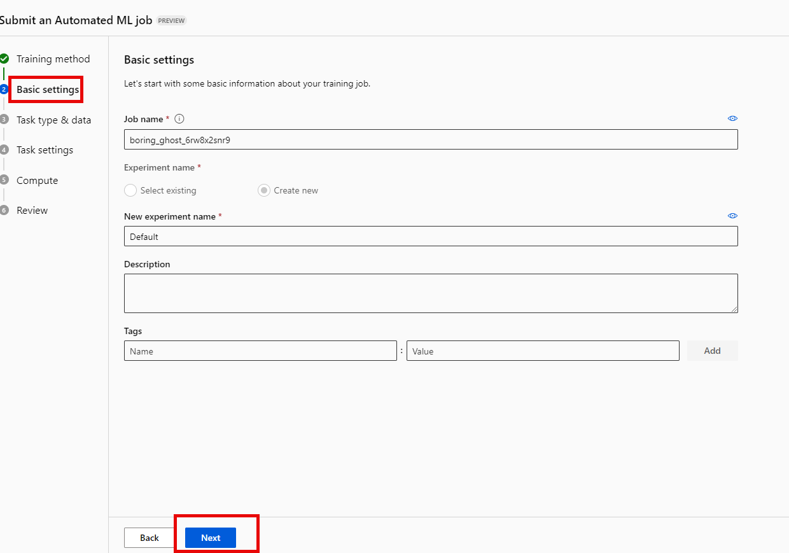

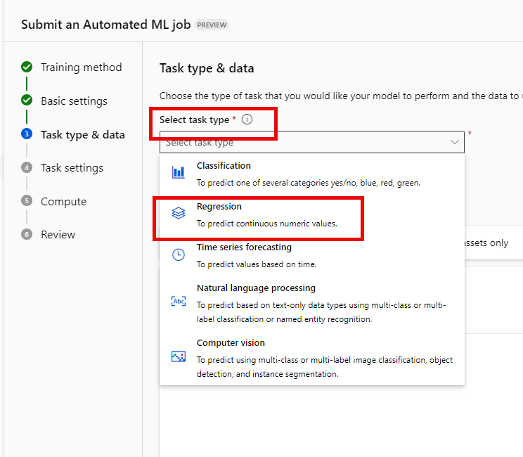

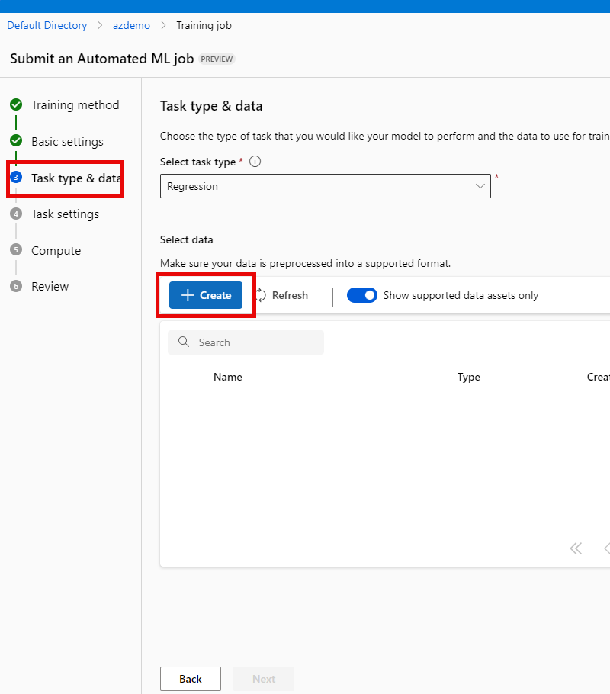

#### aka.ms/bike-rentals

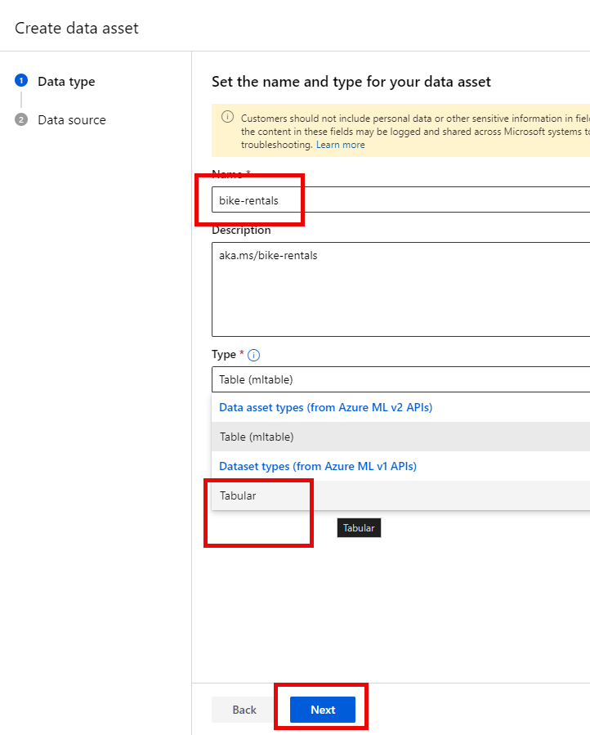

### Designer (drag drop)

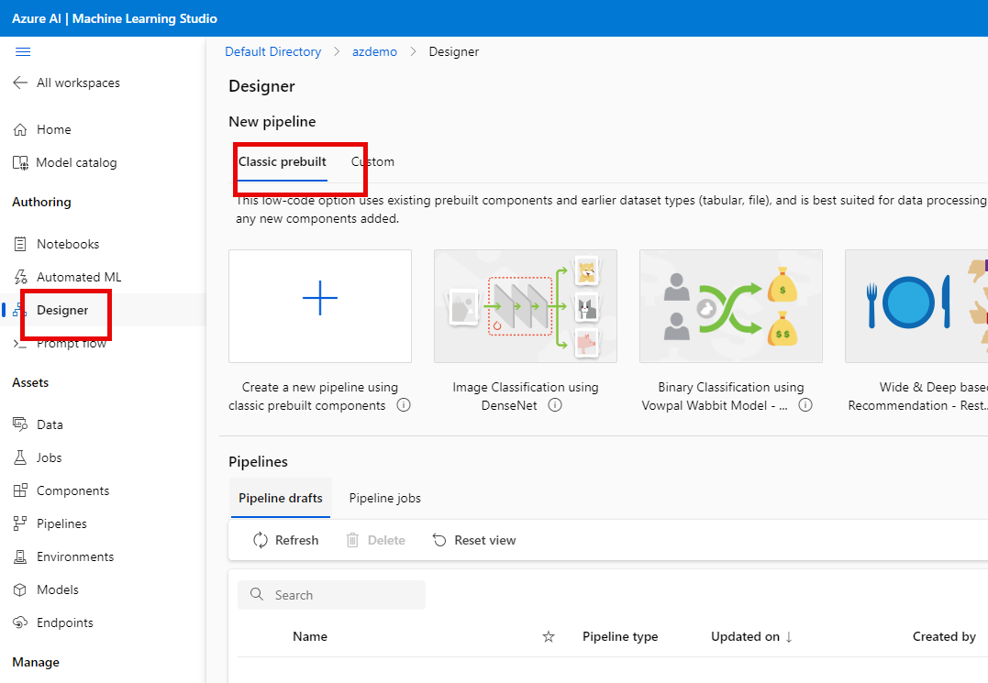

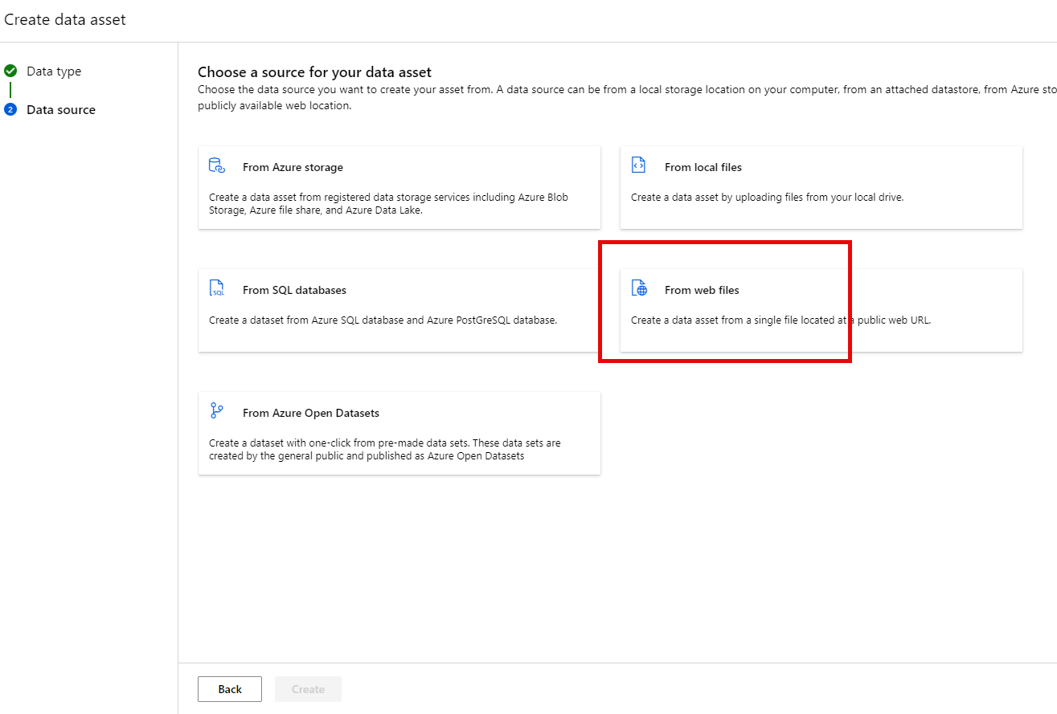

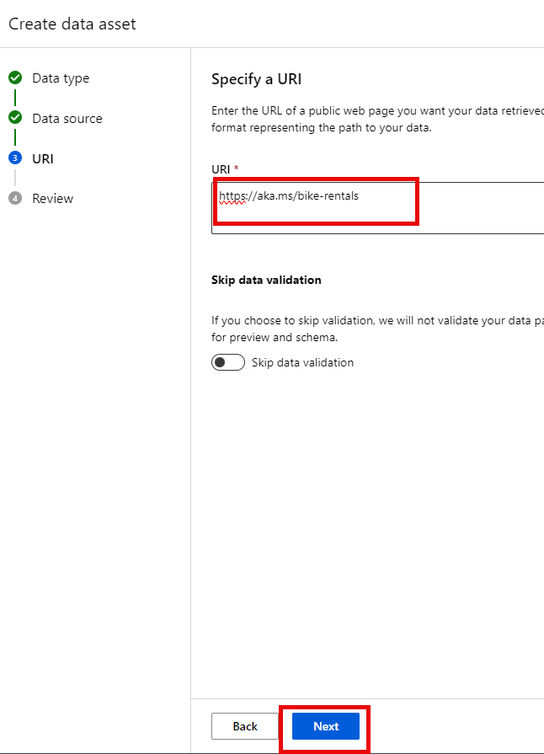

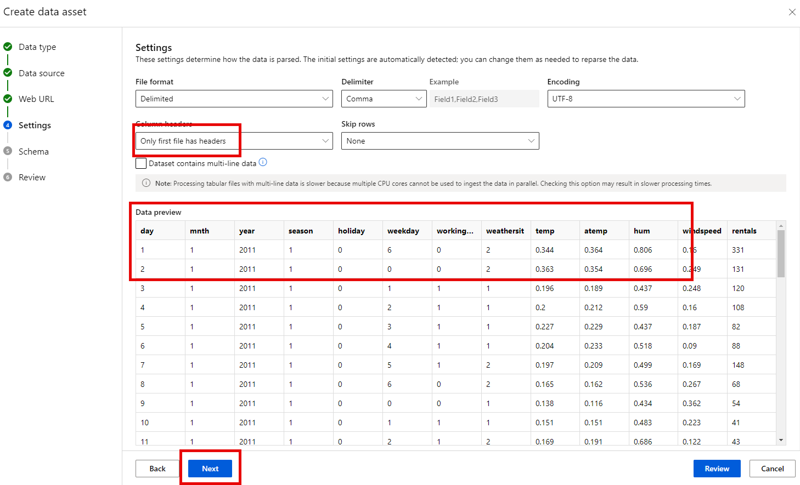

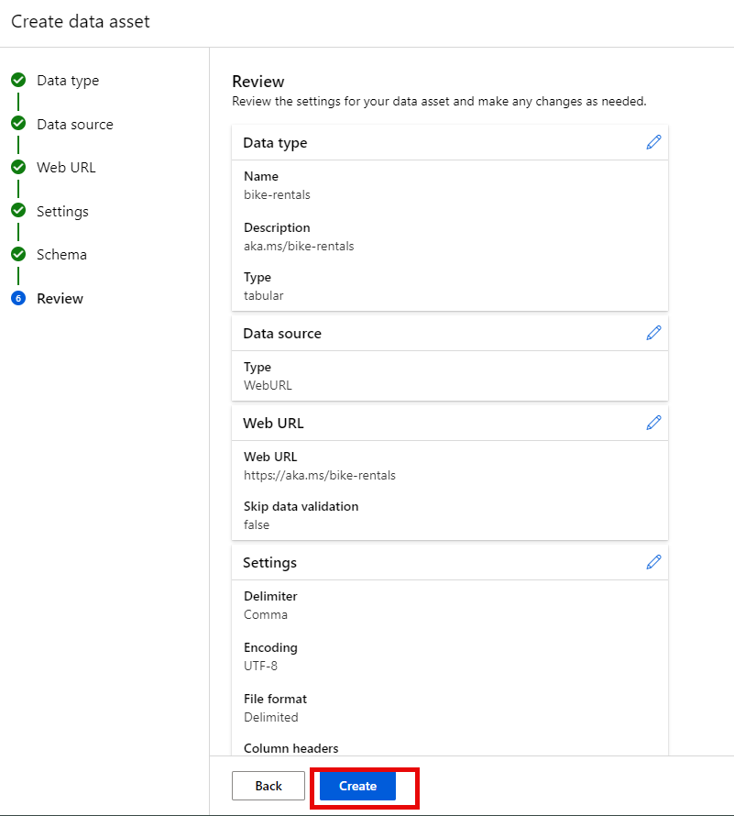

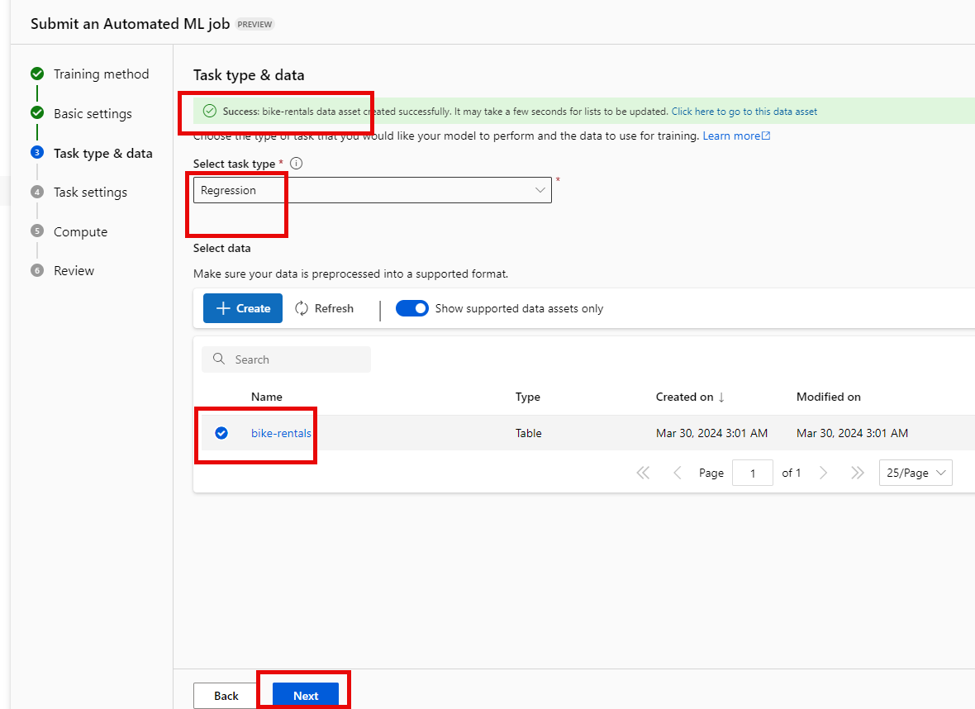

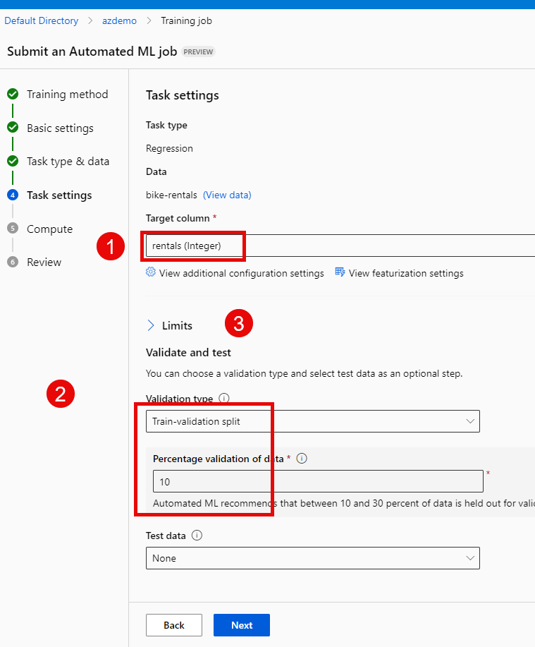

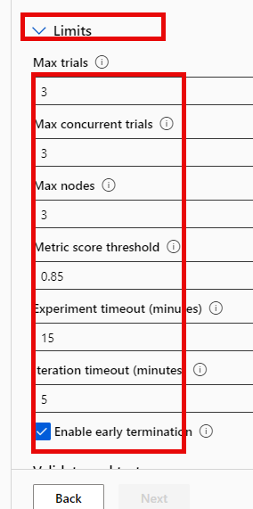

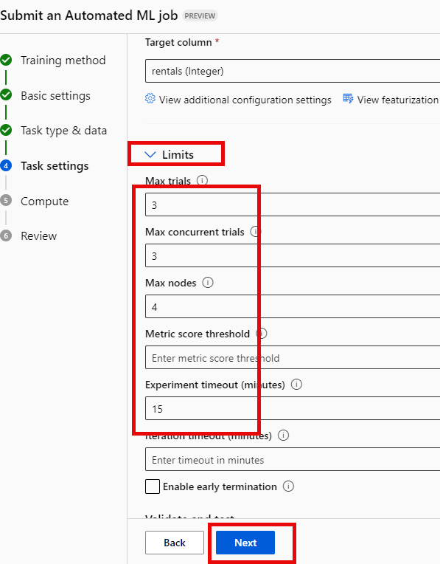

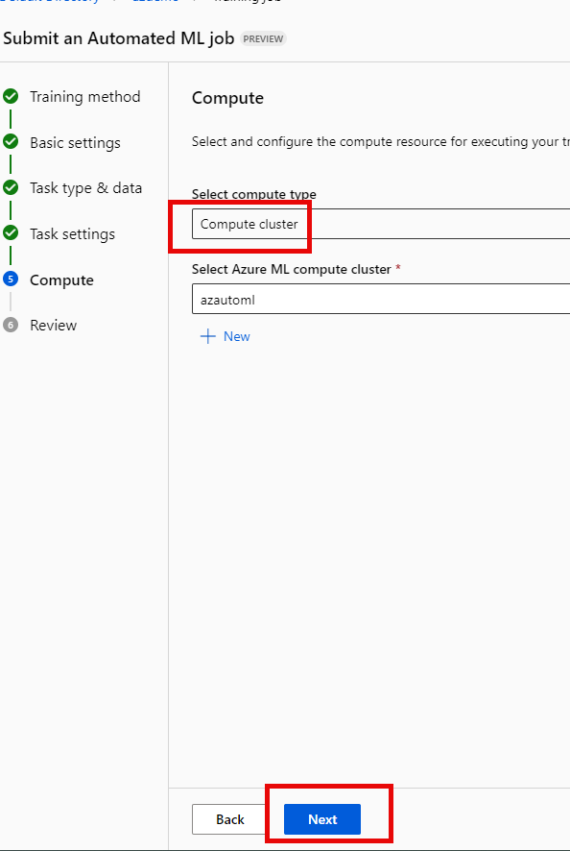

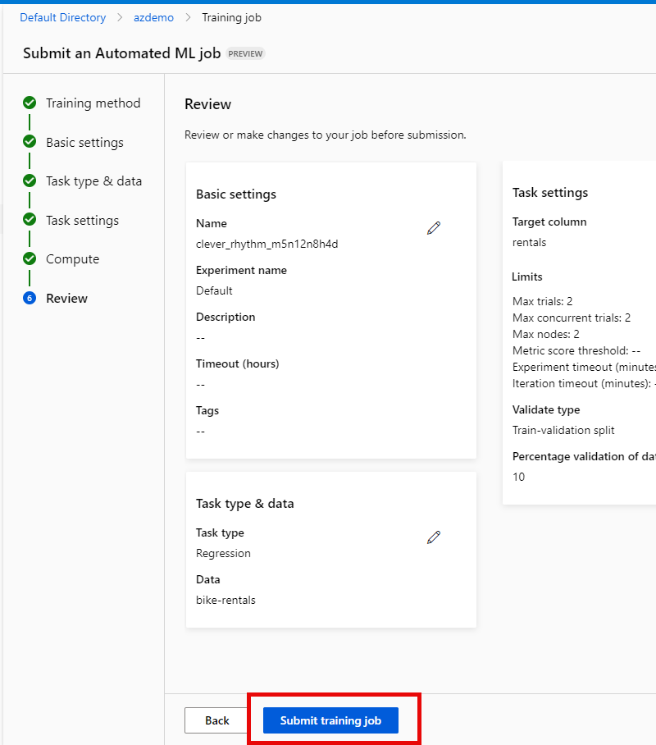

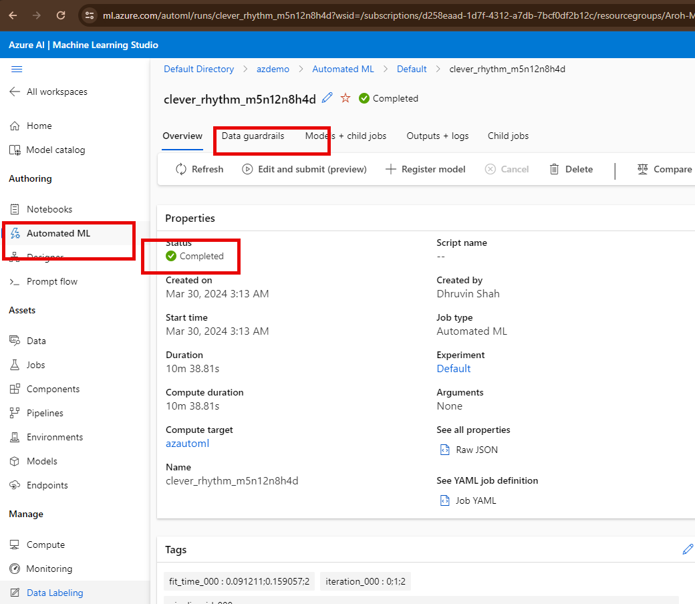

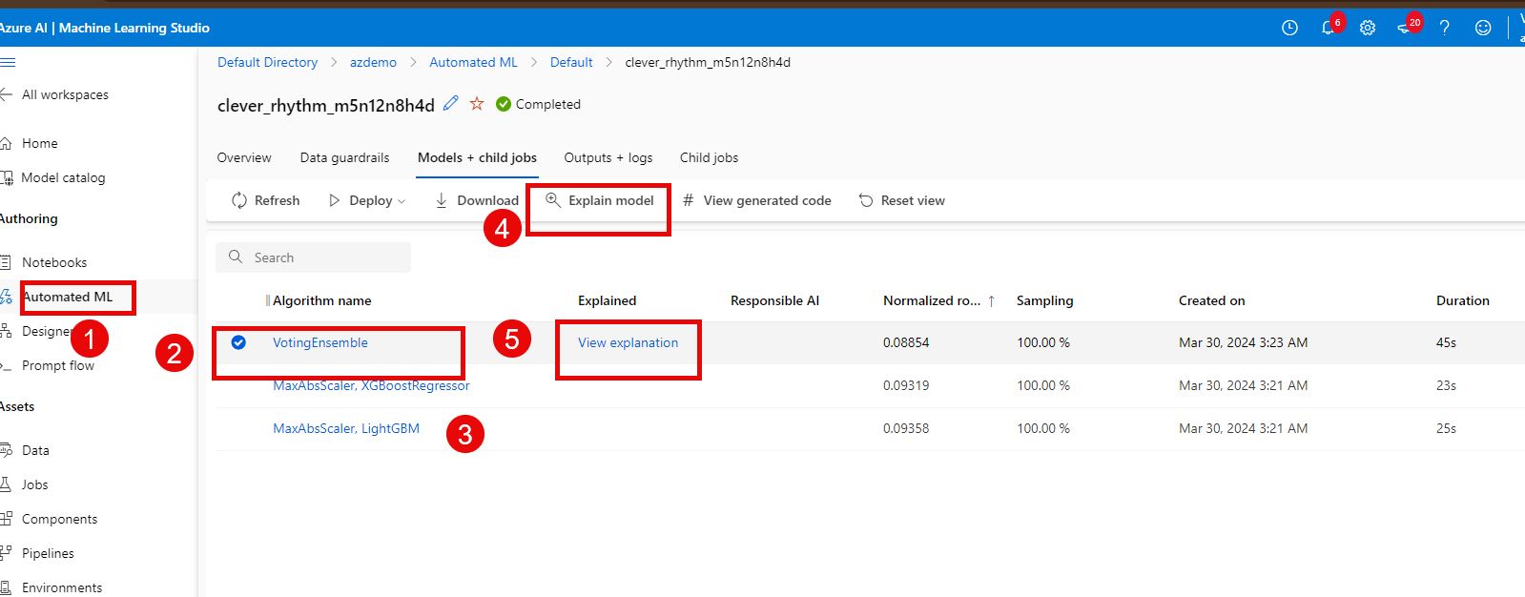

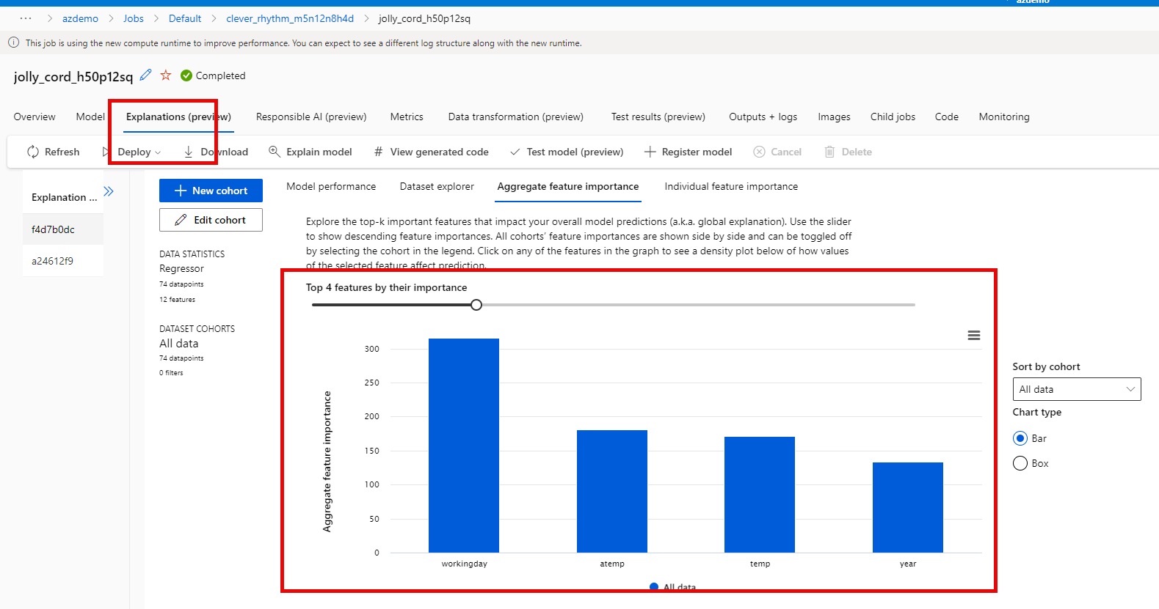

# DEMO 2: Computer Vison

## Clone Git Hub Repo

* 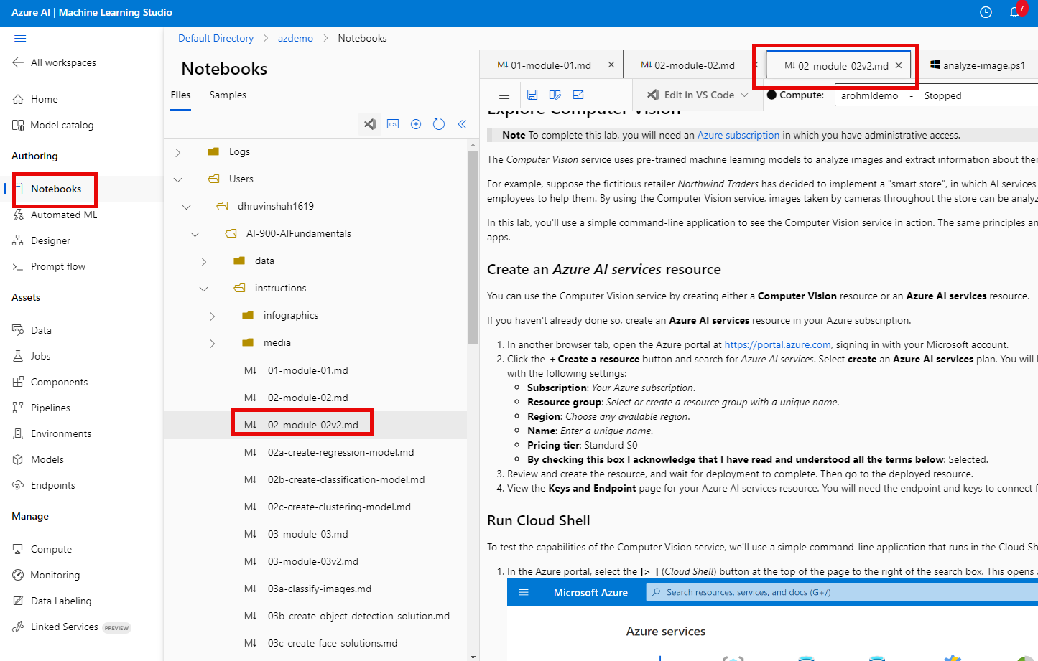
* 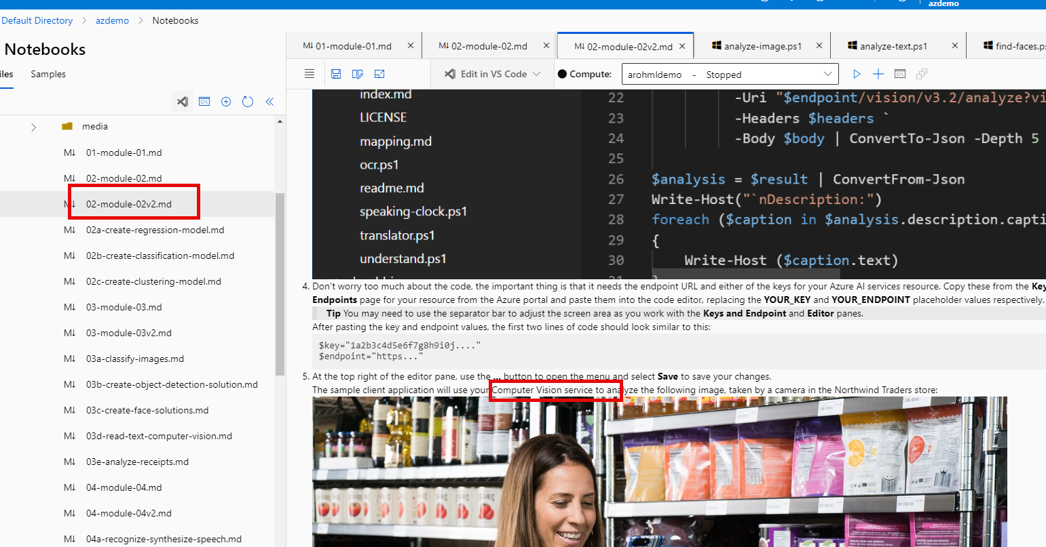
* 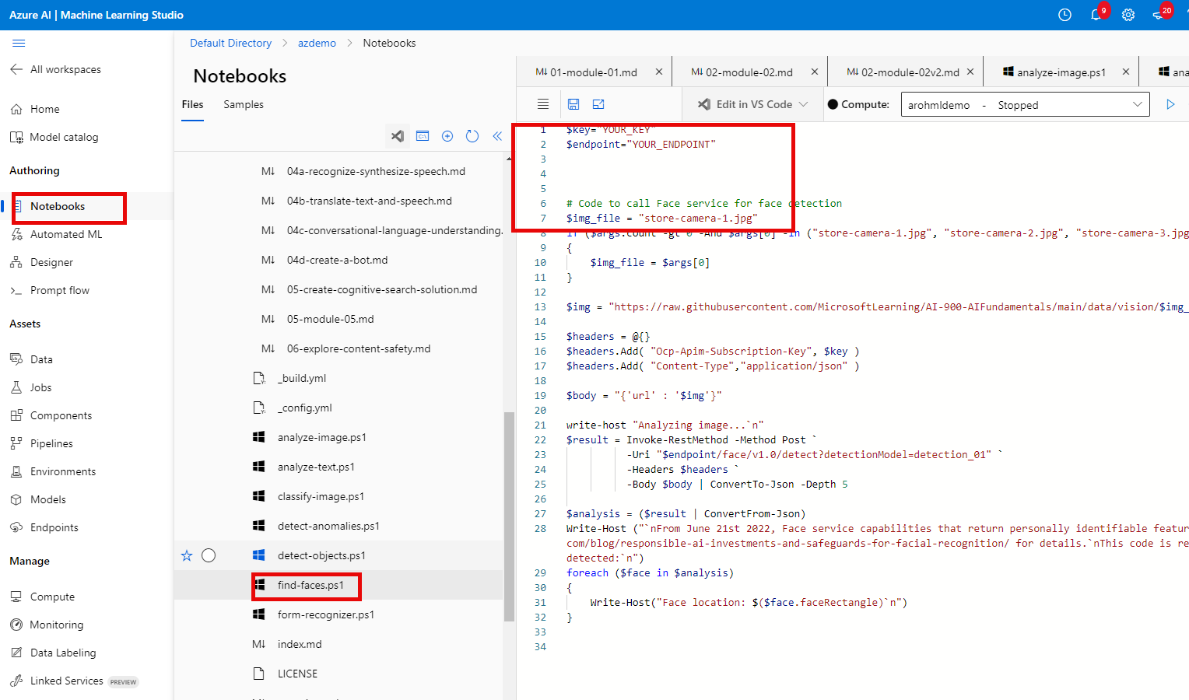

#### Create an Azure AI Service instance - Computer Vison

##### Computer vison

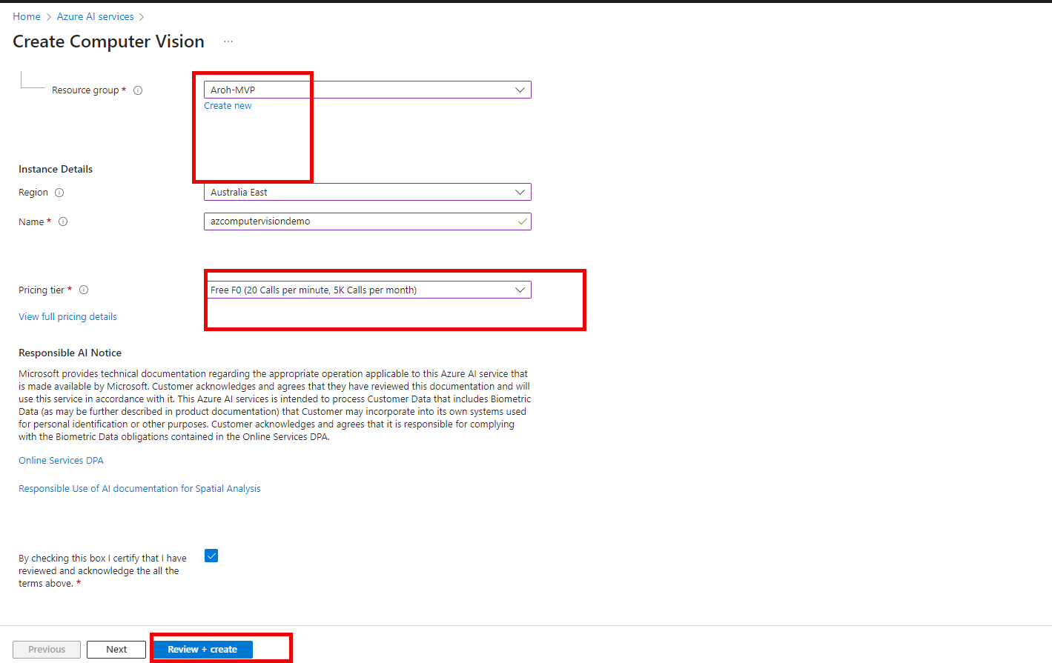

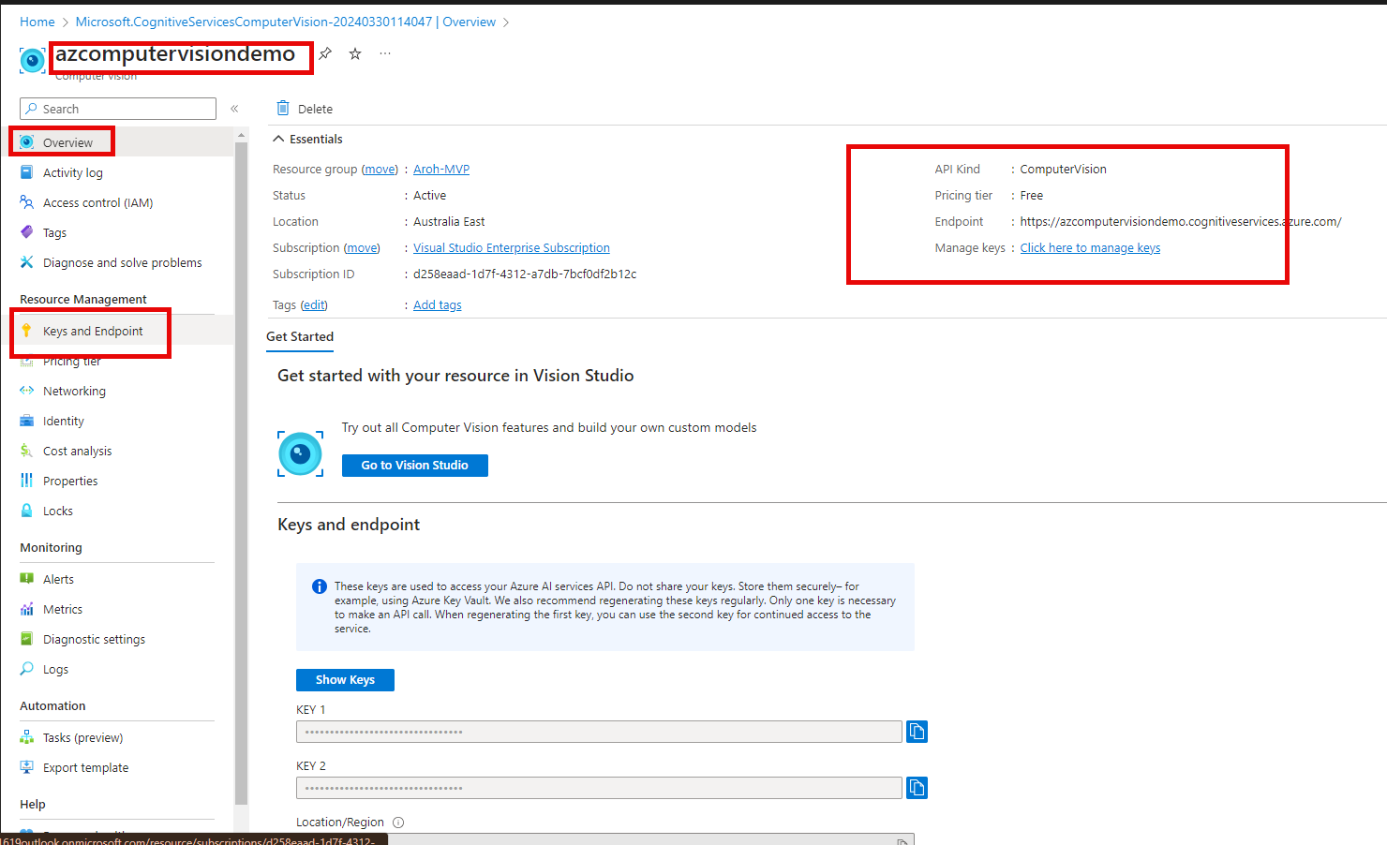

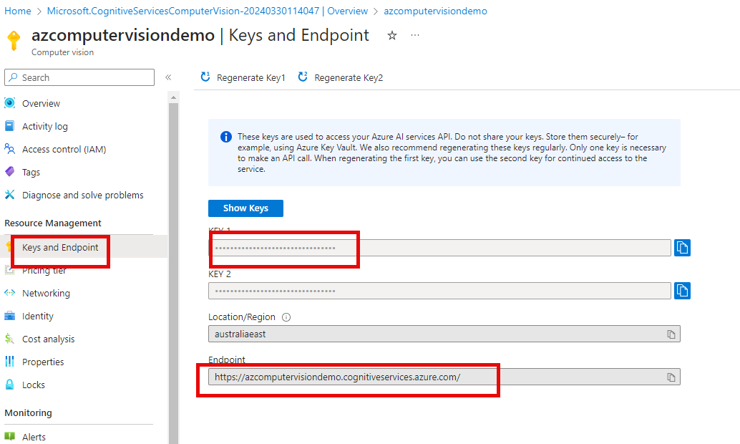

### Copy keys and endpoint in PowerShell

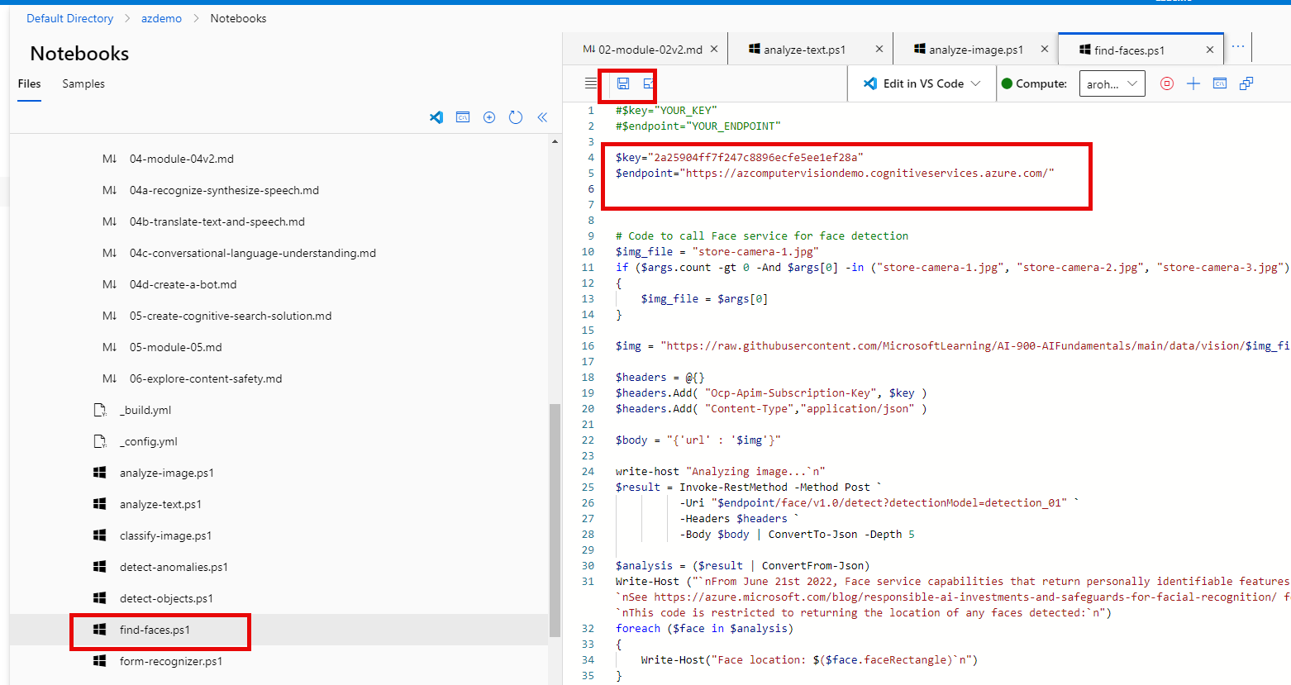

### PowerShell

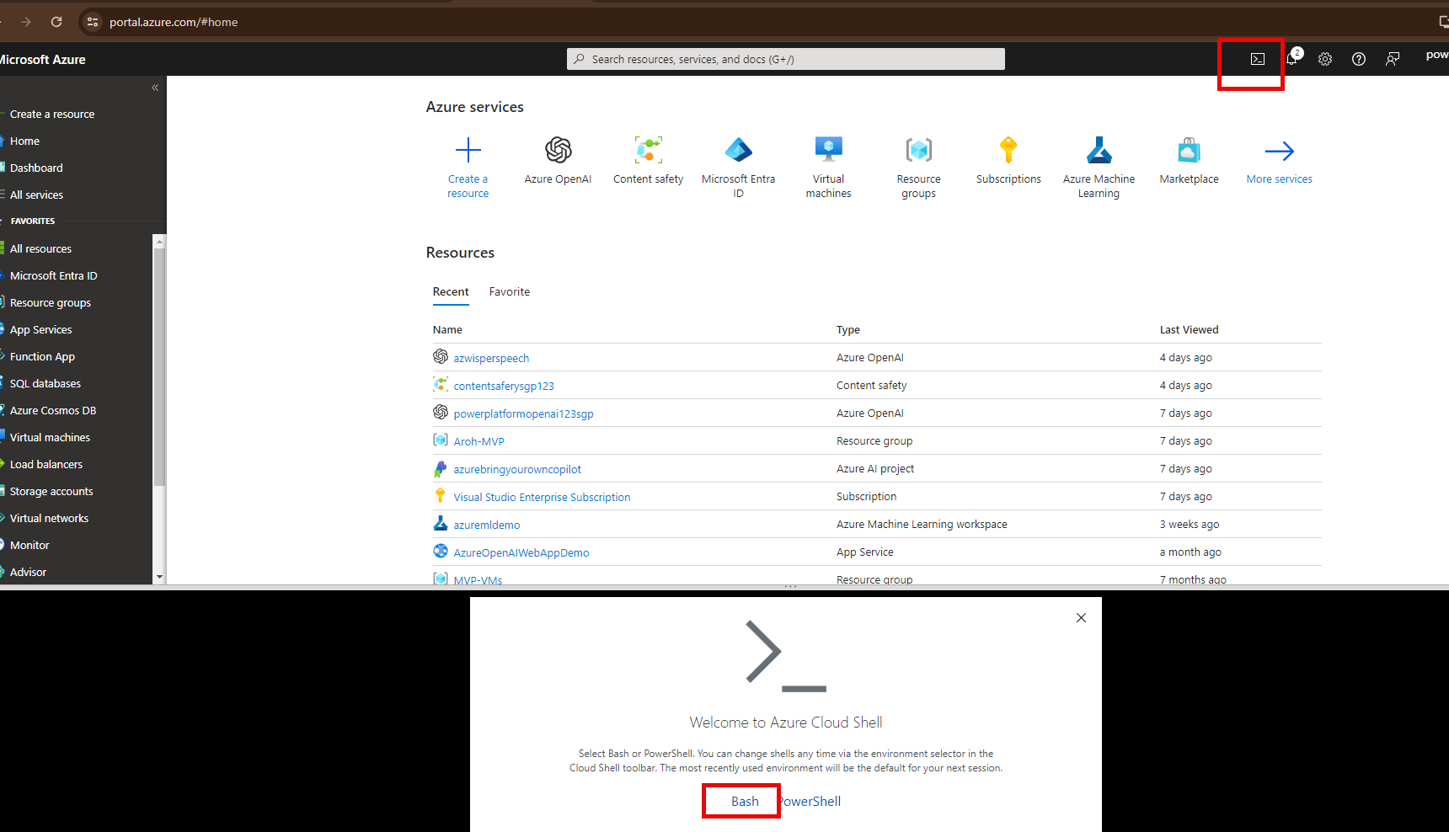

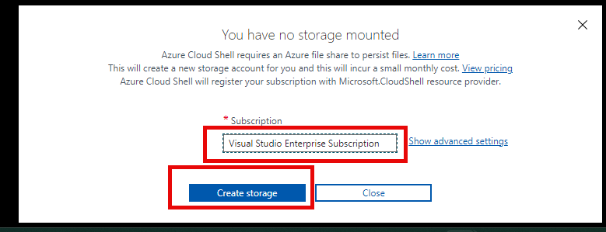

#### git clone https://github.com/MicrosoftLearning/AI-900-AIFundamentals ai-900

#### code .

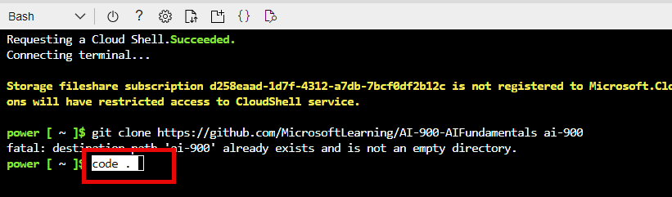

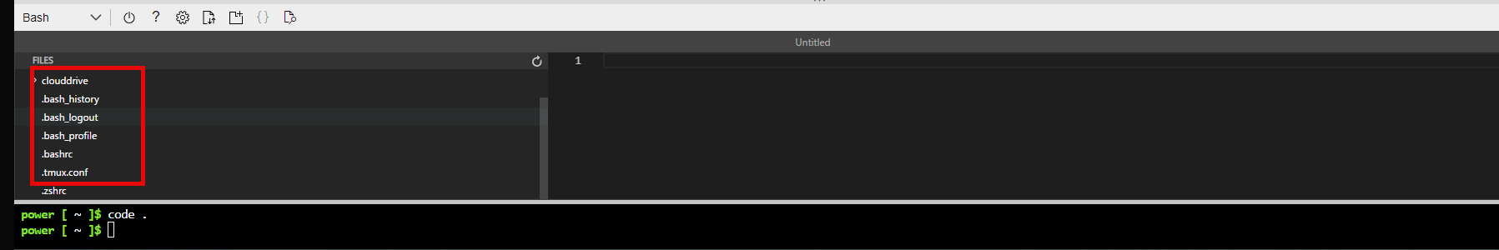

#### File >> Expand

In the Files pane on the left, expand **ai-900** and select **analyze-image.ps1**. This file contains some code that uses the Computer Vision service to analyze an image, as shown here:

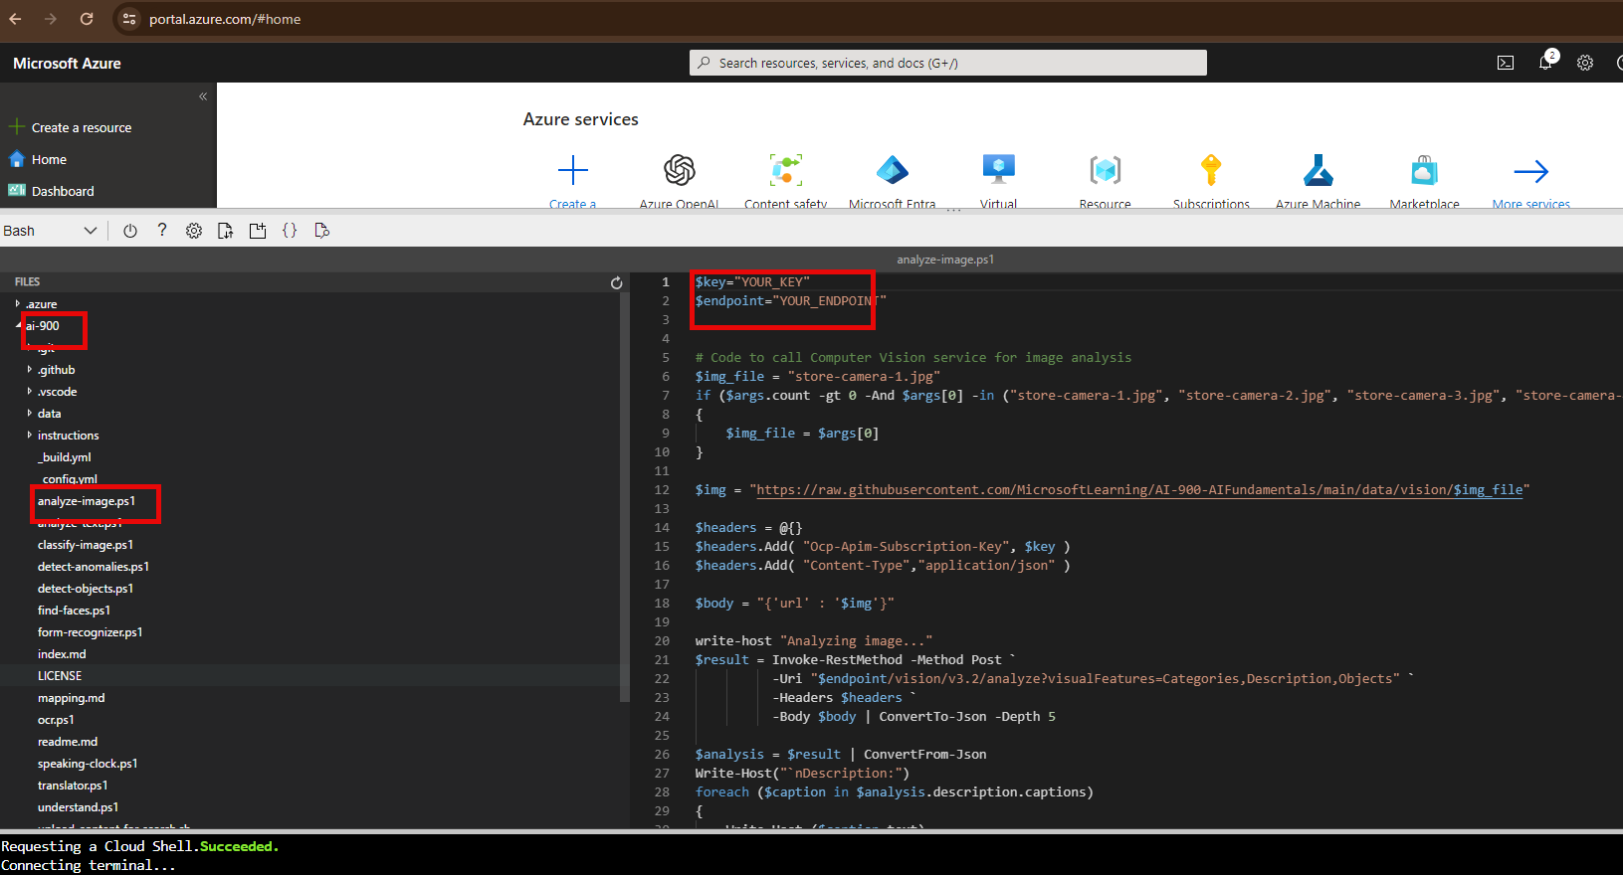

Update Key and endpoint

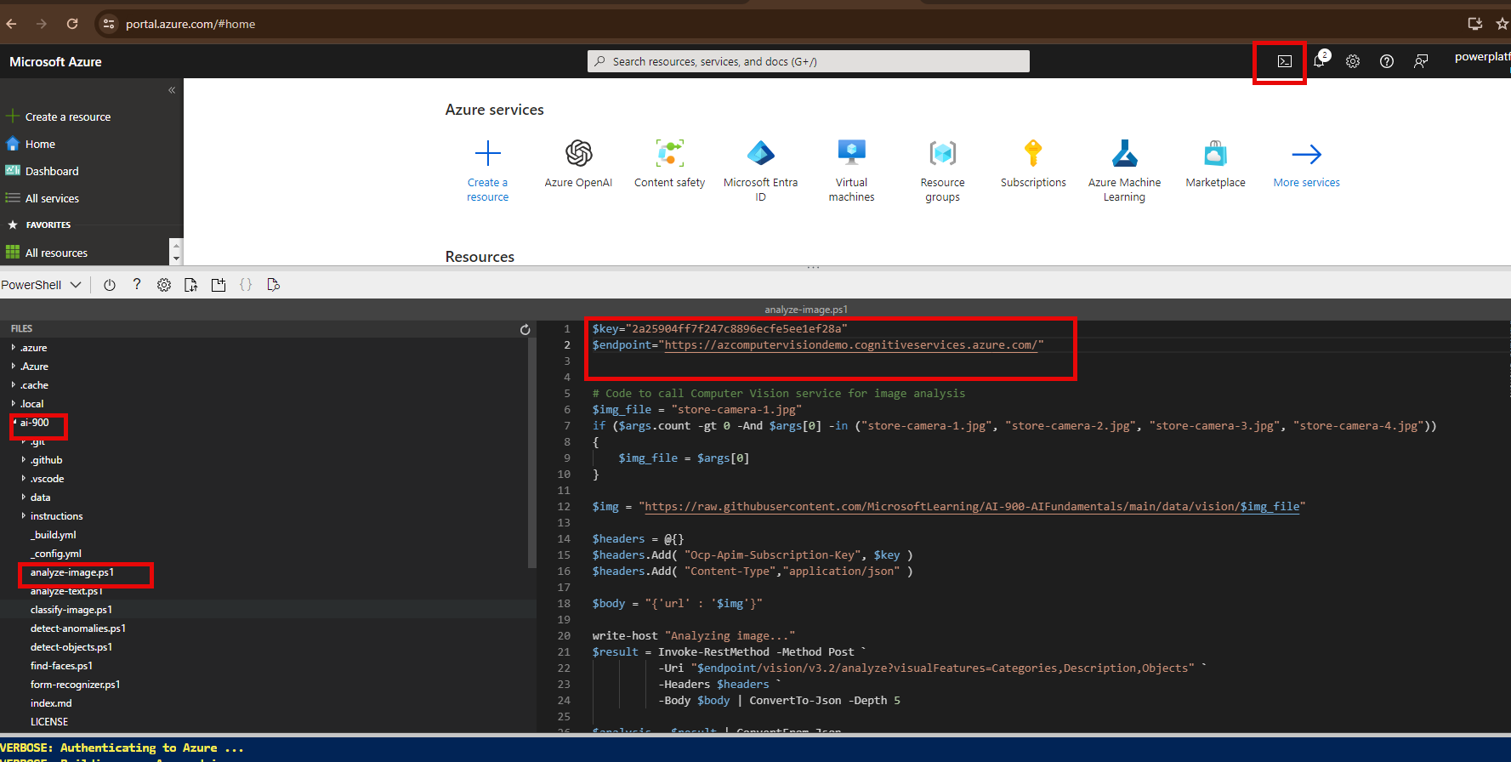

./analyze-image.ps1 store-camera-1.jpg

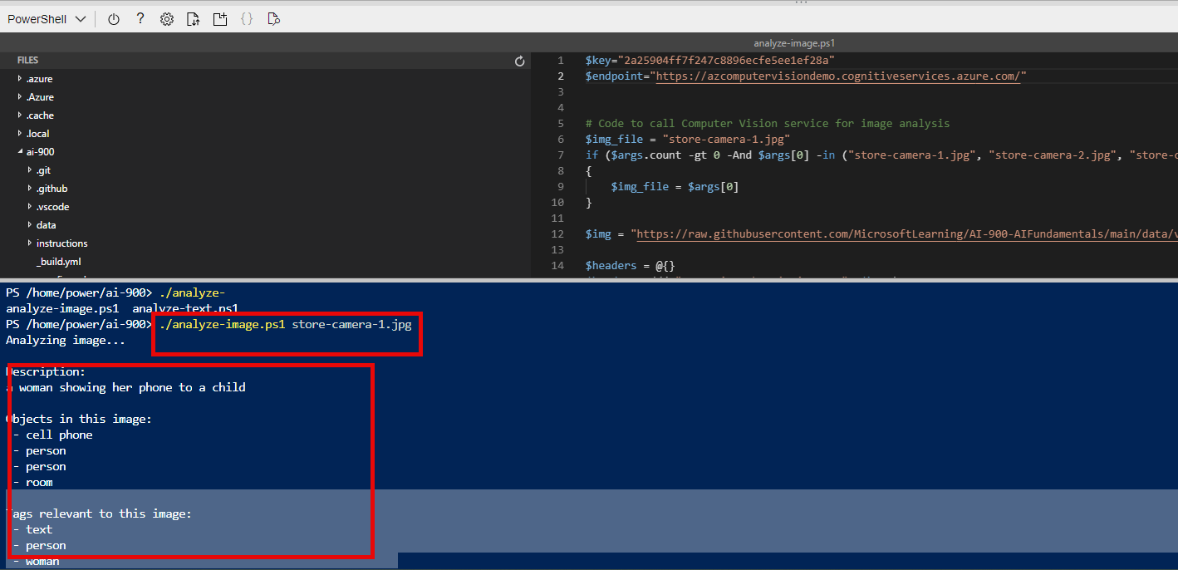

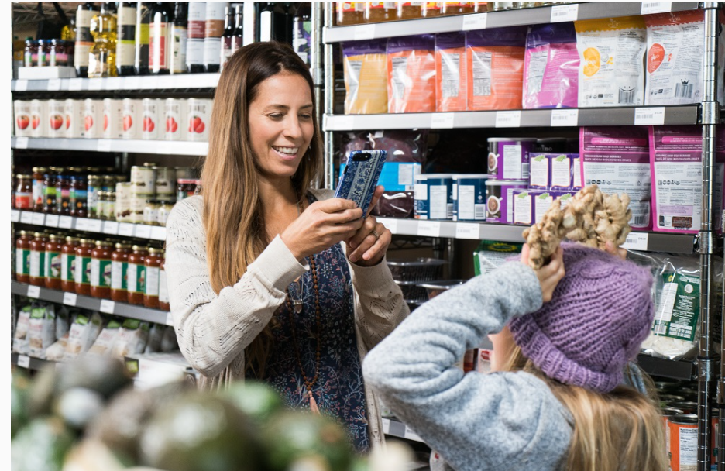

Another Example

./analyze-image.ps1 store-camera-2.jpg

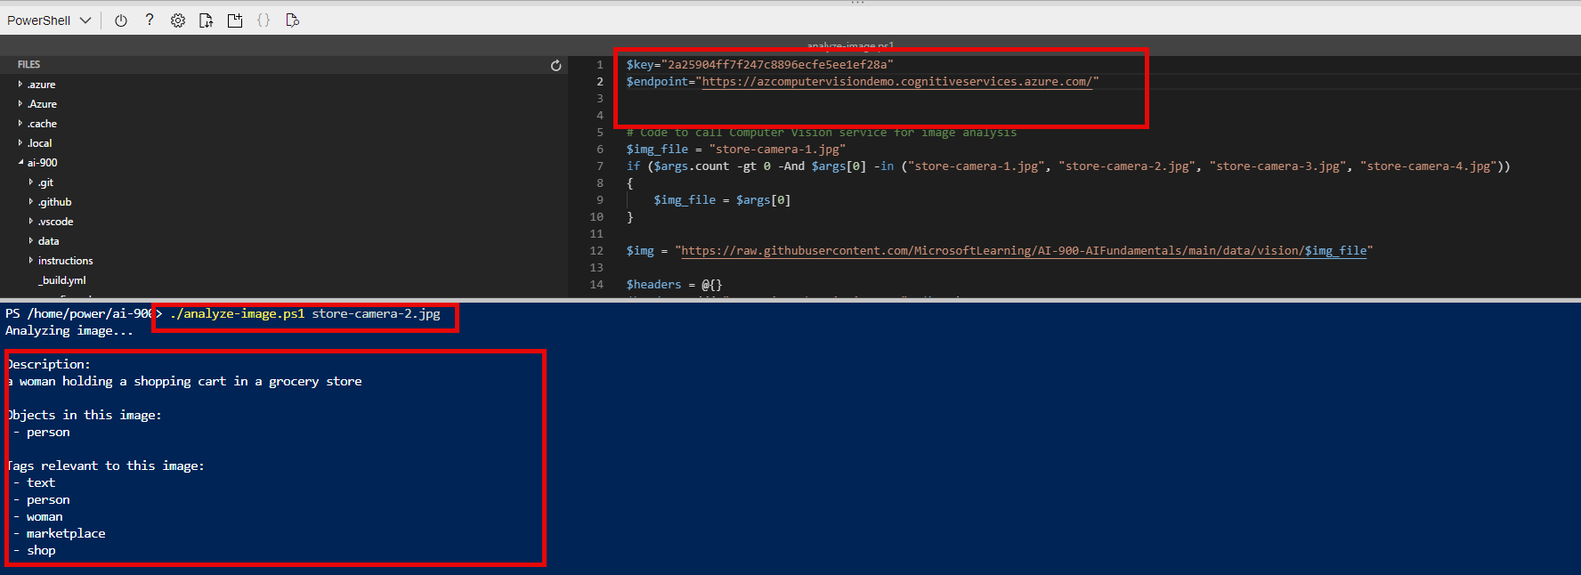

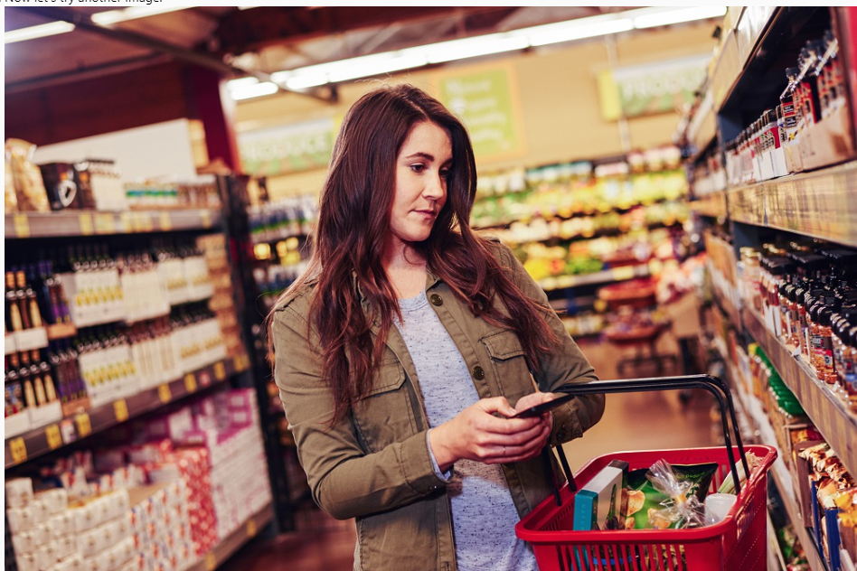

# DEMO 3: NPL

* Search for **content safety**

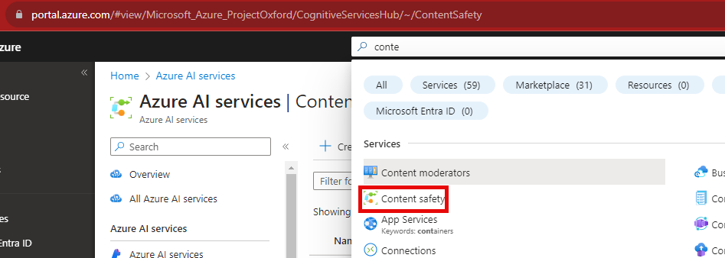

## Create a new Form Recognizer service by creating

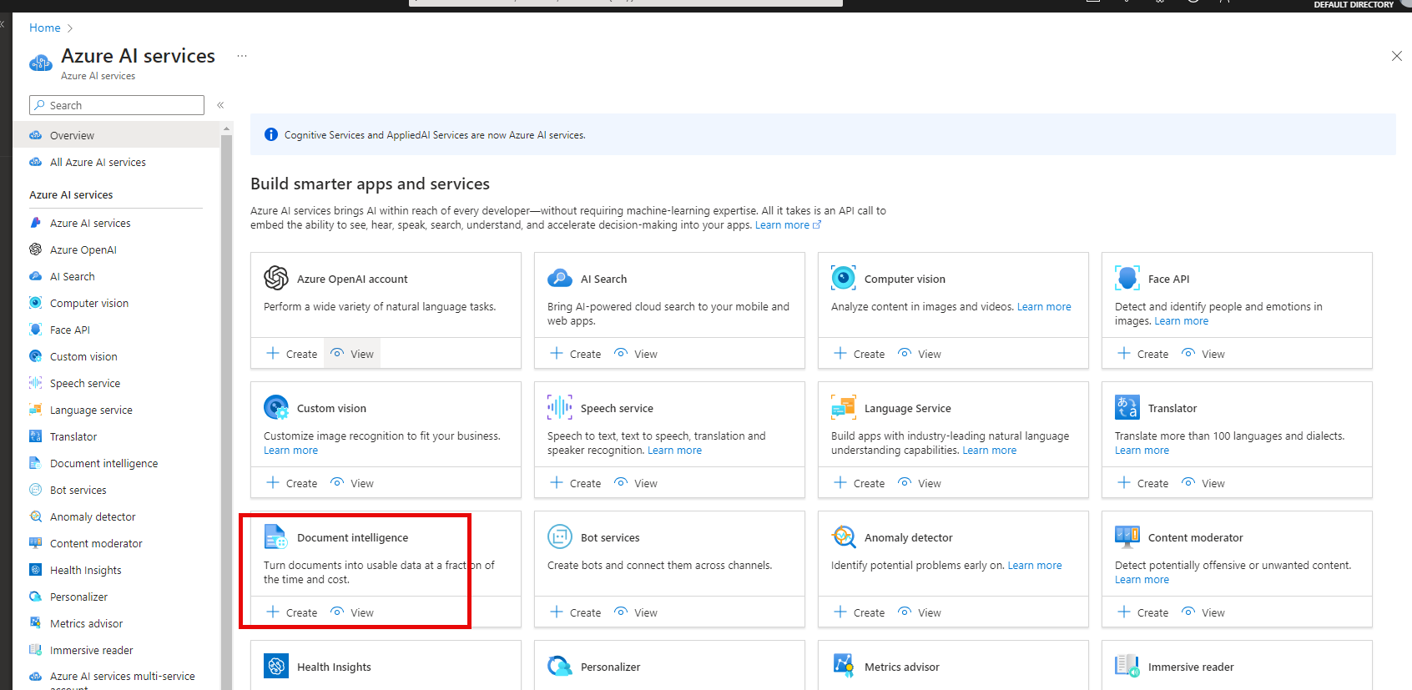

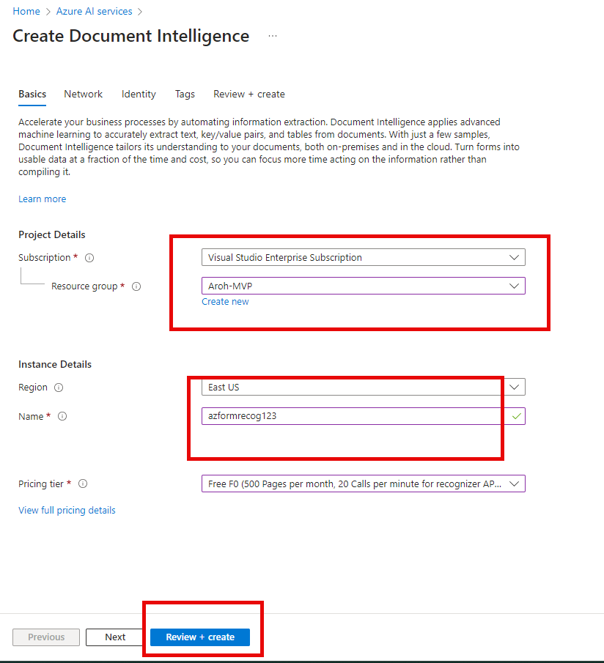

### Copy and paste keys / endpoint

### PowerShell

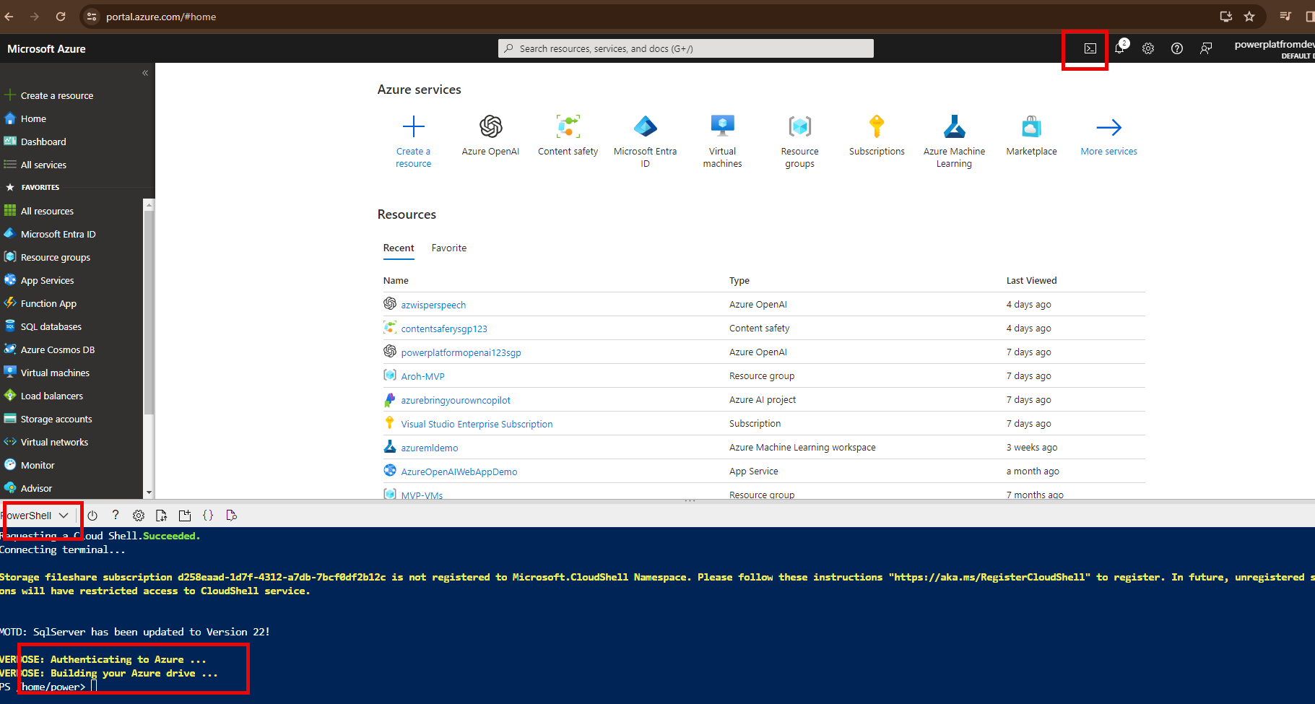

### File >> Expand

In the Files pane on the left, **expand ai-900** and select **form-recognizer.ps1**. This file contains some code that uses the Form Recognizer service to analyze the fields in a receipt, as shown here:

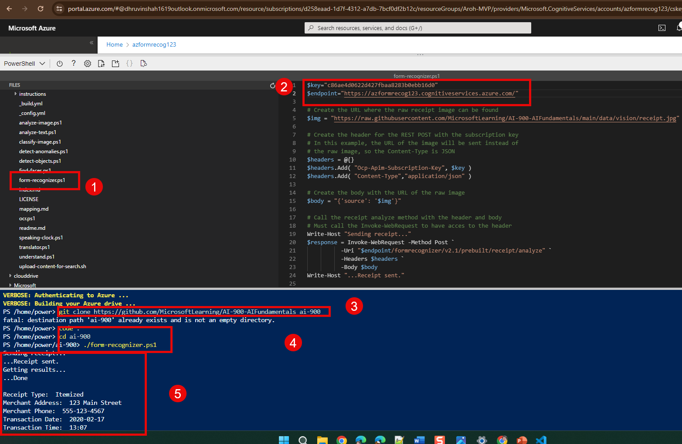

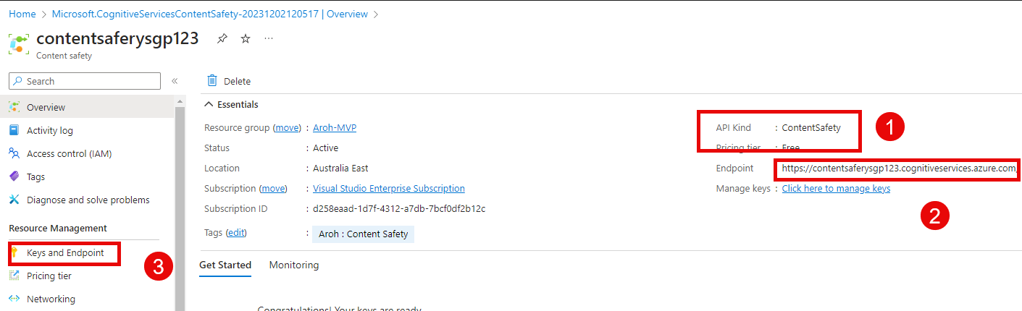

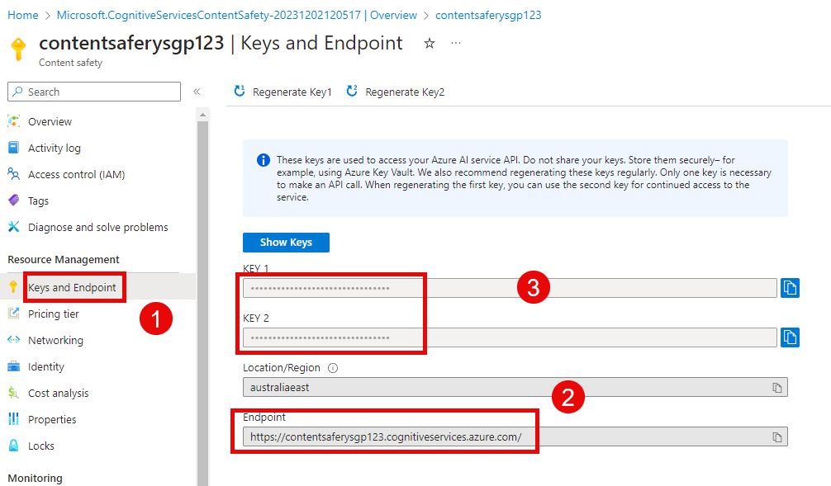

## Analyzing Text

Endpoint

https://contentsaferysgp123.cognitiveservices.azure.com/

Key

7e7df51d4d5f446b8468744a372c5bc1

Postman

### Params

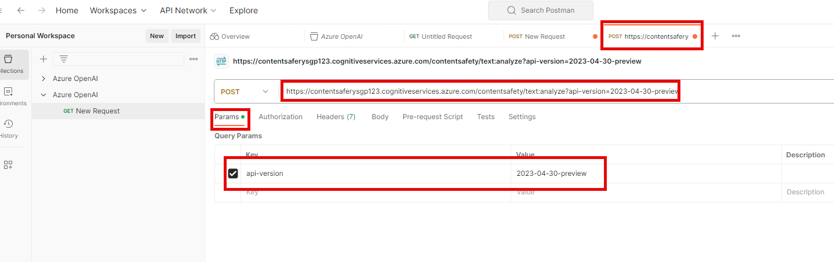

### Header

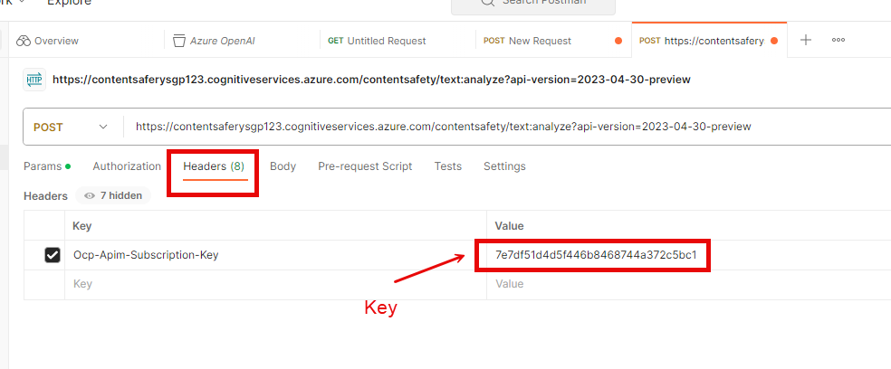

### Body :

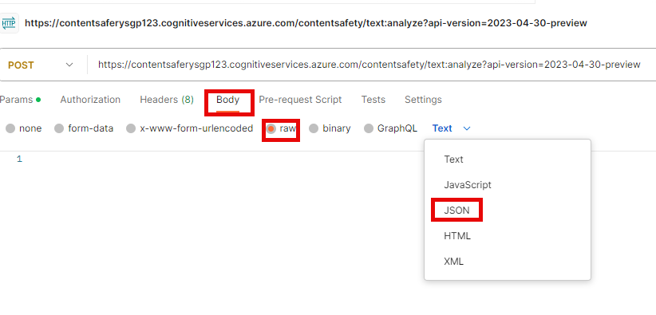

{

"text": "Sky is blue"

}

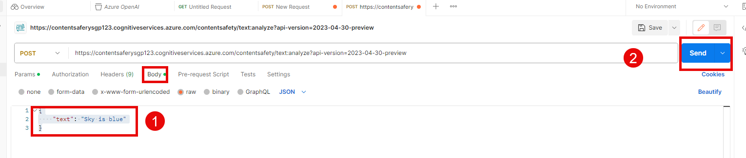

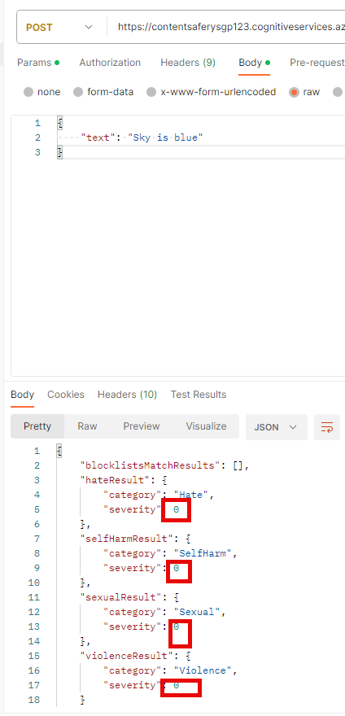

{

    "text": "I want to kill this person"

}

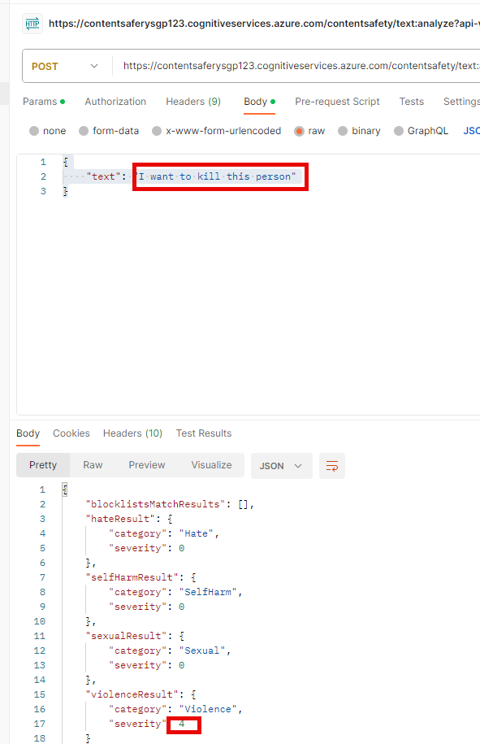

## Analyzing Images

Text moderation API endpoint

============================

<endpoint>/contentsafety/image:analyze?api-version=2023-04-30-preview

{

"image" {

"content":"<base64>"

}

}

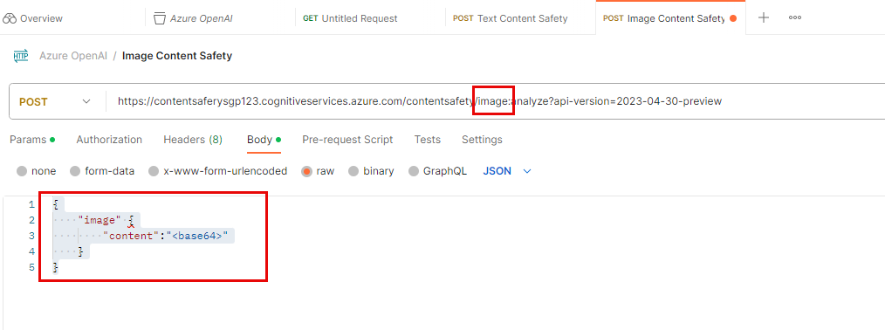

Online tool for image to base64  
<https://base64.guru/converter/encode/image>

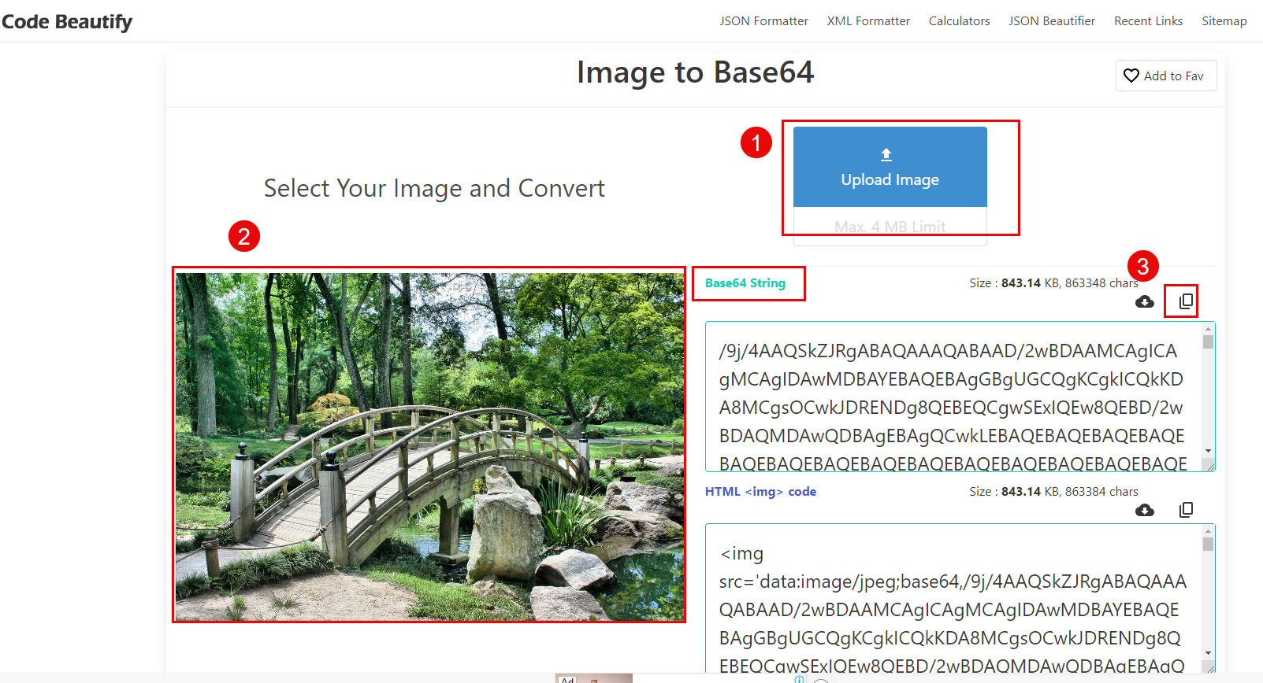

### Copy image and paste in Postman – Nature

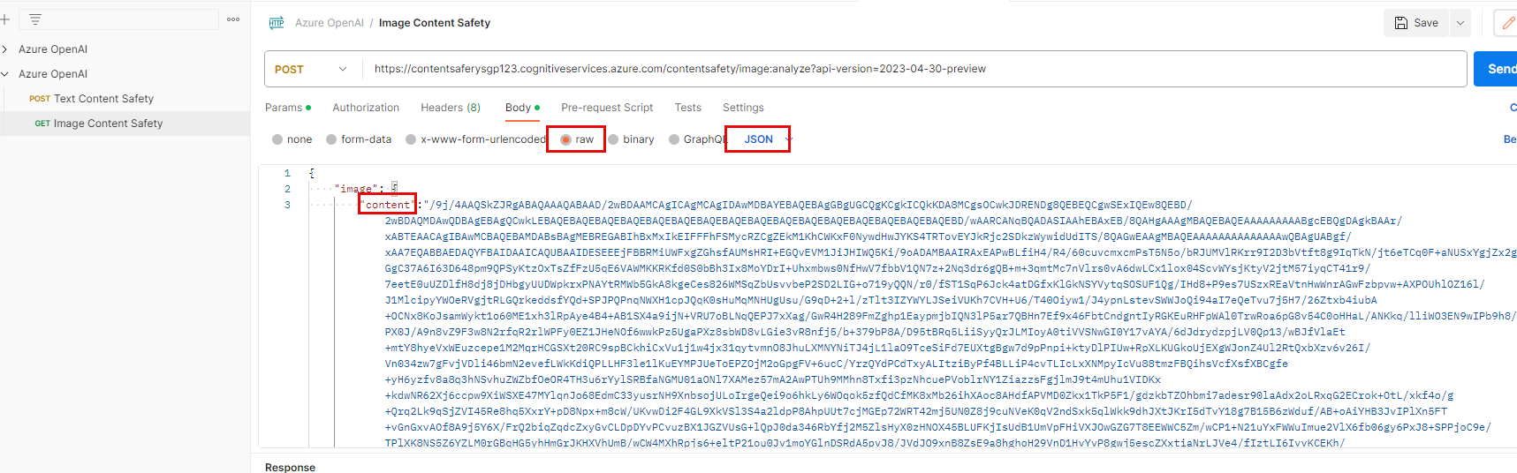

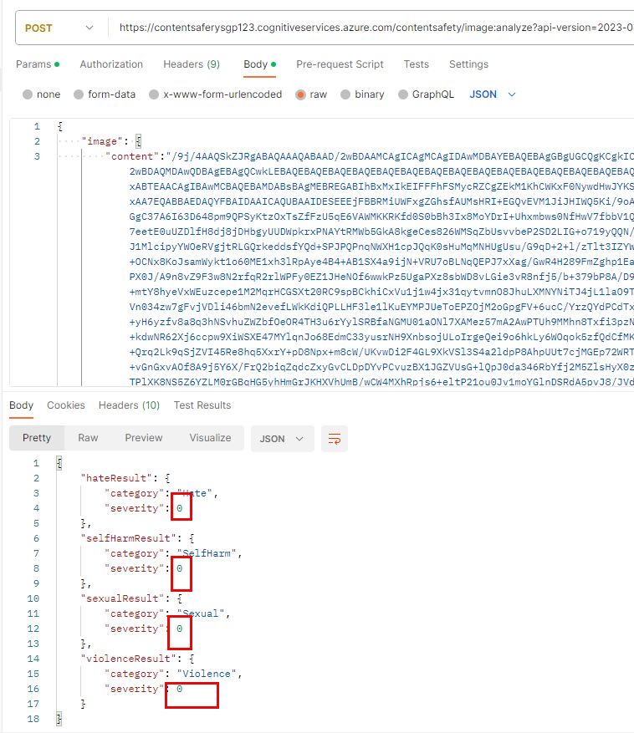

### Copy image and paste in Postman – Bullets

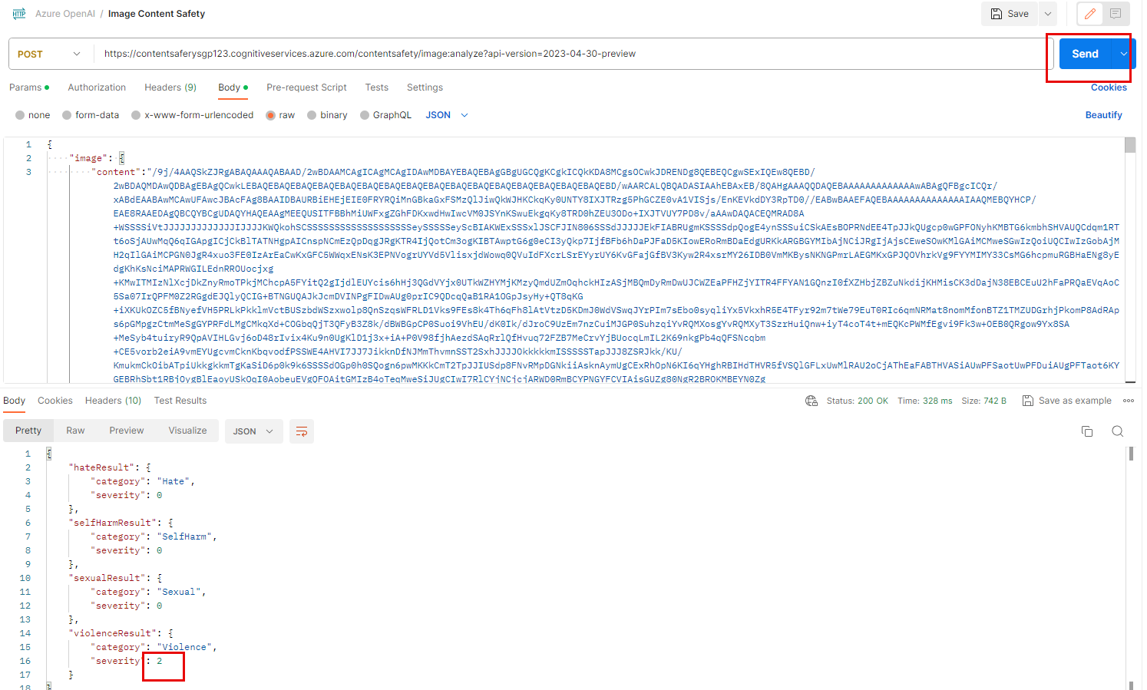

### Postman screenshots

